 | CFAS Enterprises Inc.  After Market Utility Power Equipment Brokerage  Mailto:Staff@CFASPower.com  Turbine URL: http://CFASPower.com/Index.html  Reciprocating URL: http://CFASPower.com/Recips.html
GTG_980GR_Alstom_Genend.doc

- One Unused Alstom 15000 KVA/50hz Alternator

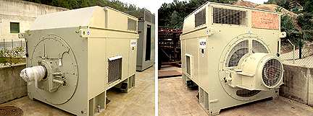

Asking price: Euro 100,000 as is, where is.
No AVR- 8-10 weeks for the new AVR.Euro 5,000

Synchronous A.C. Generator
- Manufacturer: Alstom Electrical Machines, Rugby (UK)
- Output: 15'000 kVA
- Speed: 1500 rpm
- No. of poles: 4
- Voltage: 6600 V
- Amperage: 1312 A
- Cos phi: 0.8
- Frequency: 50 Hz
- No. of phanses: 3
- Spec'n: IEC 34
- Insulation: Class F
- Altitude: 1000 m
- Rating S1 (Cont.): Class F
- Ambience : 40°C
- Excitation: Brushless
- Max. overspeed: 1800 rpm
- I.P.: 21
- I.C.: 0A1
- Coolant temp.: ? °C
- Connection: Star & neutral
- Mass: 30 tons
- Frame: T145B4
- S/N: P140954-20
- Year: 2001

