 | CFAS Enterprises Inc.  After Market Utility Power Equipment Brokerage  Mailto:Staff@CFASPower.com  Turbine URL: http://CFASPower.com/Inventory.html  Reciprocating URL: http://CFASPower.com/Recips.html
GTG_2060NC_5400Kw.doc

1 NO. 6750 kVA/5400Kw Unused, Alstom (U.K.) Make Synchronous A.C. Generator

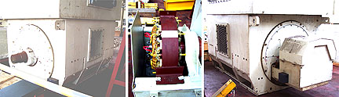

Asking price; USD 130,000
Complete Alternator, delivered ex- Warehouse, Navi Mumbai, on As Is Where Is Basis

ALTERNATOR DETAILS :

Year Of Manufacture : 1998
Condition : UNUSED
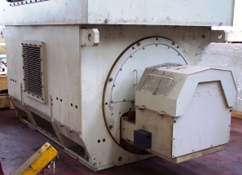
Manufacturer: Alstom Electrical Machines Ltd., Rugby, England
Frame : CGM710N2000R
Output : 6750 kVA
Speed : 1500 RPM
Voltage : 11 kV
Frequency : 50 Hz
No. Of Phases : 3
No. Of Poles : 4
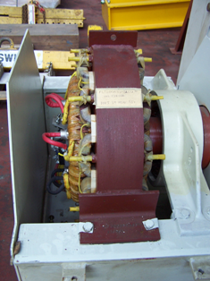
Active Power : 5400 kW
\Power factor : 0.8
Insulation (according to IEC 85 standard): Class F
Excitation : Brushless
Connection : Star + Neutral
Year Of manufacture : 1998
Enclosure : IP 44 IC1A1

Exclusions :
- Alternator Cooler.
- Panels.

Condition :
Unused; Never Installed or Commissioned.

GENERAL TERMS OF BUSINESS:

Taxes/ Duties : Whatever Applicable Will Be Charged Extra.
Terms: One- Third With Order, Balance + Taxes/Duties as applicable Before Delivery.
Delivery : Immediate, Ex- Warehouse.
Offer : Strictly Subject To Prior Sale And/Or Our Final Confirmation.

