 | CFAS Enterprises Inc.  After Market Utility Power Equipment Brokerage  Mailto:Staff@CFASPower.com  Turbine URL: http://CFASPower.com/Index.html  Reciprocating URL: http://CFASPower.com/Recips.html
GTG_1748USS_SGT800CC_50Hz.doc

200Mw Siemens (SGT-800) Complete Combined Cycle Power Plant
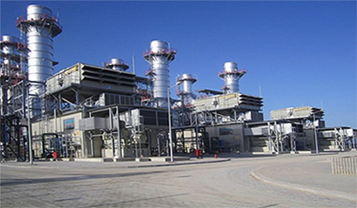
Asking Price: USD $42MM
Installed Capacity: 200 MW
Energy Production Capacity: 1640 GWh/year
Commissioning Date : 16.06.2013
Configuration: 3 X SGT-800 GT + 1 x ST
Total Gross Efficiency/Net Efficiency: 55% / 53.6%
DESCRIPTION OF POWER PLANT
The Power Plant is composed of 3 Gas Turbines (Siemens SGT- 800) and 1 no of Steam Turbine (Siemens SST-900), 3 nos of HRSG (Aalborg-Denmark), 1 no of ACC (SPX-Belgium), 1 no of RMS station, HV switchyard and BOP equipment.
The generated electricity is transmitted to high voltage Switchyard through 154 kV 2x1272 MCM overhead transmission line.
The plant was commissioned as simple cycle in August 2012 and as combined cycle in June 2013.
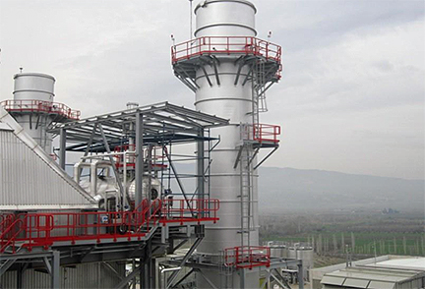
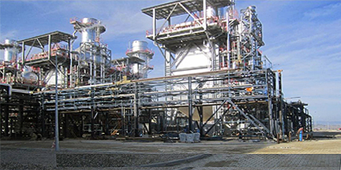
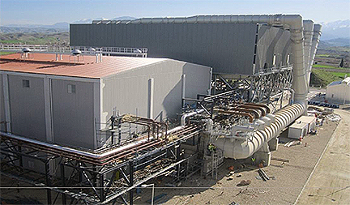
HISTORY
 | GT1 | GT2 | GT3 | SST900
Operational Hours since COD | 15197 | 14762 | 15452 | 17399
Number of Start Stops | 915 | 929 | 822 | 549
Equivalent Hours | 21085 | 21489 | 22034 | 9801
EOC | 1177 | 1345 | 1316
Operational Hours after B Inspection | 2547 | 2493 | 2582 | 2613
Number of Start Stops after B Inspection | 218 | 233 | 238 | 262

Hi Scott,

I have a attached a brief summary of the equipment which is all the information we have currently.

The owner has said the whole plant could be sold for $40mil. I do believe their is some wiggle room in there though. How much I am unsure.

BR,
John

John Webb ACMA, CGMA
​USP&E
www.uspowerco.com
www.uspeglobal.com

