 | CFAS Enterprises Inc.  After Market Utility Power Equipment Brokerage  Mailto:Staff@CFASPower.com  Turbine URL: http://CFASPower.com/Index.html  Reciprocating URL: http://CFASPower.com/Recips.html
GTG_1744TT_Fm6_50Hz.doc

2 x Used 50Hz GE FM 6 40Mw Dual Fuel 11Kv Complete Power Plants

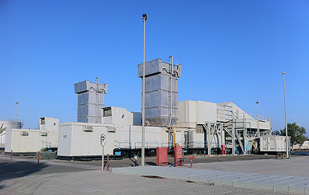

Download Specifications and Histories

Price: USD $6 MM
FOB Dubai

The price excludes all other charges inland transportation, customs, shipping charges etc.

