 | CFAS Enterprises Inc.  After Market Utility Power Equipment Brokerage  Mailto:Staff@CFASPower.com  Turbine URL: http://CFASPower.com/Index.html  Reciprocating URL: http://CFASPower.com/Recips.html
GTG_1740_AEGFm5BMT_50Hz.doc

1 Simple Cycle AEG FM-5N 25.6MW 50Hz Power Plant

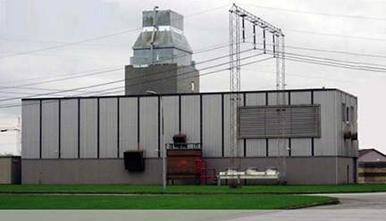

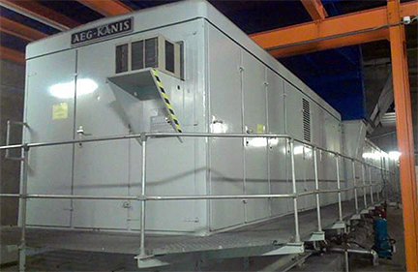

Asking Price: 575.000 Euro
As It Is Where It Is: Location Europe).

Introduction

Configuration: 1 x Skid, Simple Cycle, Single Shaft, Heavy Duty Gas Turbine With Diesel Start, Generator And All Necessary Auxiliary Equipment.

The Complete Gas Turbine Plant Has Been Maintained Regularly By Professional Companies. The Owner Has Kept Record Of The Operational Data And Reports Of All Maintenance Events During Its Operational Life Time And Is Available For Further References.

Operation Data

During Its Operational Life Time The Unit Has Accumulated, Under Base Load Conditions, The Following Operational Data:

Total Fired Hours: 2.230 Hrs.
Fired Starts: 1.674 Hrs.
Operation Hours: 1.928 Hrs.
Start Up Time From Stand Still To 100% Load: 15 Minutes
Load Change

Technical Equipment Data

Gas Turbine

Gas Turbine Type: GE Frame 5 (5341n)
Manufacturer: AEG-Kanis
Fuel: Distillate Oil
No. Compressor Stages: 16
No. Turbine Stages: 2
No. Fuel Nozzles: 10
Rpm: 5100
Net Power Output: 25.6 Mw
Net Heat Rate: Mw12,900 kj/kwh
Exhaust Gas Flow: 118 kg/s
Exhaust Gas Temperature: 515 °C
Nox Emission: No Values Available
Usage: Black Start

Generator

Manufacturer: Rade Koncar
Type: S 1726 – 2
Nominal Power: 32 MVA
Nominal Active Power: 25.8 Mw
RPM: 3000
Cos phi: 0.8
Frequency: 50 Hz
Nominal Voltage: 10.5 Kv
Nominal Current: 1,760 Amps
Cooling Principal: Air
Type Of Excitation: Brushless

Gear Boxes

Load Gear Manufacturer: Graffenstrade
Type: BA 1 EK
Auxiliary Gear Box Manufacturer: Graffenstrade

Gas Turbine Control System: Speedtronic Mark V
Generator Excitation: ABB Unitrol 5000
Generator Protection: ABB Type REG 216
C02 Firefighting Control: Kidde

Dimensions

Overall Length: 39 Meters
Width: 3.2 Meters
Height: 3.8 Meter

Maintenance History

1999: The Control System Was Upgraded In 1999 Till Speedtronic Mark 5 With Local And Remote Operating Possibilities.
2007: New Generator Exciter System ABB UNLTROL 5000 And ABB Generator Protection System Type REG 216.
2008: Major Overhaul Of Load Gear
2010: Replacement Of Air Intake Filters And Lube Oil Pumps
2011: Replacement Of Fuel Nozzles, Non-Return Valves And Combustors 2013 New Fire Protection System

**Last Scheduled Maintenance Event Was A Hot Gas Path (HGP) Inspection And Was Executed In 2008.

