 | CFAS Enterprises Inc.  After Market Utility Power Equipment Brokerage  Mailto:Staff@CFASPower.com  Turbine URL: http://CFASPower.com/Index.html  Reciprocating URL: http://CFASPower.com/Recips.html
GTG_1737PEEN_W501D5_60HZ.doc

600MW 6 x 1995 Westinghouse W501D5 (60HZ) CC Gas Turbine Power Plant

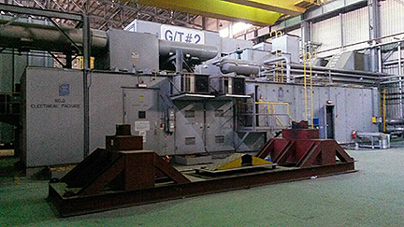

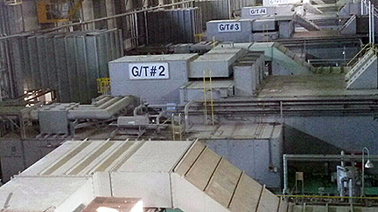

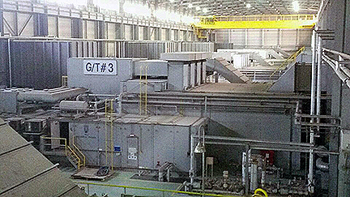

Asking Price: US $2.9MM Each

Gas Turbine Generator Sets

Rating: 100Mw
Quantity: 6 Units
Frequency: 60hz
Fuel: LNG
Build in: 1995
Stopped Operation: June 2013

Gas Turbines

Manufacturer: WESTINGHOUSE (SIEMENS)
Model Name: W501D5
Type: Axial Flow
Power Output: 100, 000kW(100MW) Each
Stages: 4 stage
Inlet Temp.: 1093 ℃
Exhaust Temp.: 530 ℃
Exhaust Flow: 1313272 kg/h
TAC Temp.: 15℃
Speed Governor: DEHC

Starter System

Type: Electric Motor
Capacity: 1530 kW
Quantity: 1 Each

Combustor

Type: Can-Annular
Quantity: 14 Each

Compressor

Type: Axial Flow
Air Mass Flow: 358 N㎥/min
Inlet Temp.: 15℃
Pressure Ratio: 14:01
Outlet Pressure: 14.462 kg/㎠
Stages: 19 Stage
Outlet Temp.: 389 ℃

Generators

Manufacturer: WESTINGHOUSE (SIEMENS)
Type: OAC (Open-Air-Cooled)
Rated Power: 129(143) MW(MVA)
Power Factor/ Short-Circuit Ratio: 90%/0.695
Frequency: 60Hz/2 pole
Speed: 3600 RPM
Rated Voltage/Current: 13.8 kV/5731 A
Insulation Class: F

Exciter

Speed: 3600 RPM
Exciter Type: PMG
Rated Voltage/Current; 325 V/1006 A
Protection Devices: 87G, 59GN, 40, 32, 46, 51V, 60, 25
Neutral Grounding: NGR
Bus Bar: IPB (3phases)
Rotation Direction: CW (Viewed Form Exciter end)

Operation Hours

Gas Turbine #1: 37,566 Hours (1996.1~2013.6)
Gas Turbine #2.: 7, 013 Hours (1996.1~2013.6)
Gas Turbine #3: 39,800 Hours (1996.1~2013.6)
Gas Turbine #4: 41,541 Hours (1996.7~2013.6)
Gas Turbine #5: 41,819 Hours (1996.7~2013.6)
Gas Turbine #6: 40,524 Hours (1996.7~2013.6)

Operation Hours From Overhaul To Stop

Gas Turbine #1: 18, 117 Hours
Gas Turbine #2: 16, 611 Hours
Gas Turbine #3: 17, 098 Hours
Gas Turbine #4: 15, 686 Hours
Gas Turbine #5: 17, 978 Hours
Gas Turbine #6: 16, 921 Hours

Generator Serial Number

Generator #1: 93P0621
Generator #2: 93P0623
Generator #3: 93P0635
Generator #4: 93P0684
Generator #5: 93P0695
Generator #6: 93P0694

Scope Of Supply

Turbine
Generator
Control Panel (Electric Package)
Switchgear Box
Mechanical Room Equipment
Currently Installed With Target Dismantling Schedule During 2016

