 | CFAS Enterprises Inc.  After Market Utility Power Equipment Brokerage  Mailto:Staff@CFASPower.com  Turbine URL: http://CFASPower.com/  Reciprocating URL: http://CFASPower.com/Recips.html
GTG_1735TM_Fm6C_CC_127Mw.doc

1 x 2005 127mw 50Hz 2 x GE FM 6C Combined Cycle Power Plant

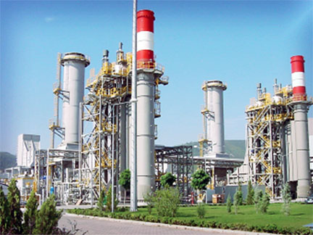

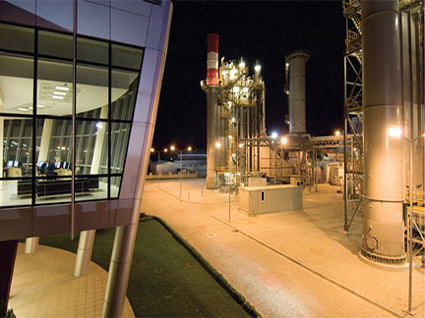

Asking Price

Plant: $9,500,000
Dismantling: $3,350,000
Packing: $400,000
Documentation - Marking: $300,000

Turbines Only $3,000,000 For Each

Download Additional Info:

General Information and Technical Specification

List of Equipment

List Of Spares

1 x 127mw combined cycle power plant in turkey (2*GE Frame 6c + 1*GE steam turbine). Can be offered turnkey project company, dismantled, transported and installed at clients site location.

The plant is a combined cycle gas turbine (CCGT) power station and one of a series of efficient, environmentally friendly stations. The plant was first commissioned in A April 2005 running at base load. In the Plant there are two GE Frame 6C gas turbines and one GE steam turbine with a total of 127 MW installed capacity. GE has supplied a GE 206C combined-cycle package, which includes two Frame 6C gas turbine-generators and one GE steam turbine-generator. GE Power & Water sees the MS6001C (6C) gas turbine units as the fleet leader of the 6F.01 reintroduced in 2014 to address high combined cycle and cogeneration efficiency need below 150 MW.
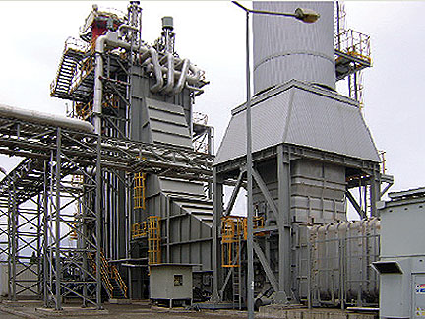
GAS TURBINE
The plant has two GE Frame 6C gas turbines, which each can produce 42,3 megawatts of electricity. Gas turbines underwent a combustion inspection in 2014.
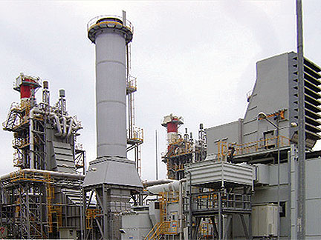
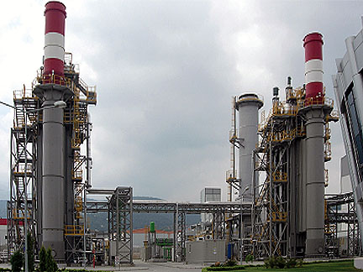
STEAM TURBINE
The steam turbine is a GE Vacumend with combined HP/LP. Steam from the heat recovery steam generator (HRSG) drives the single steam turbine, which has a power output of up to 40,8 megawatts of electricity from its associated generator. The turbine consists of a combined high pressure and low-pressure stage. The steam turbine underwent a major inspection in 2012.
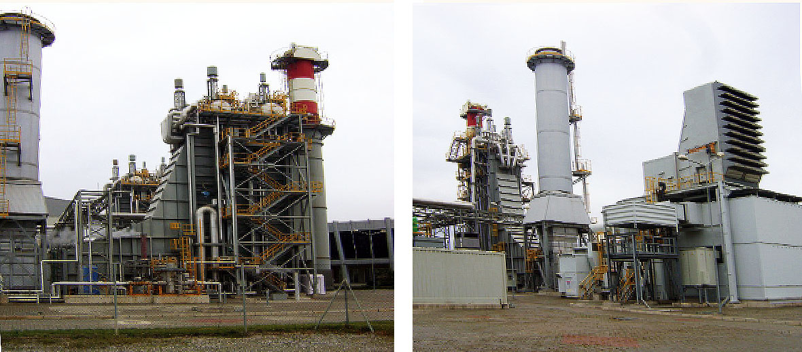
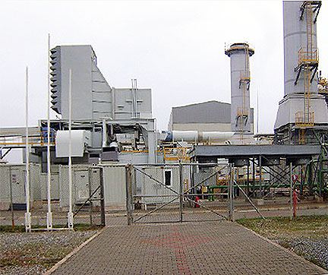
CONDENSİNG
The plant utilizes under ACC.
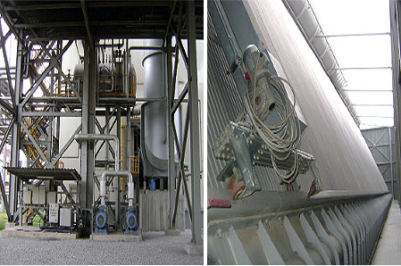
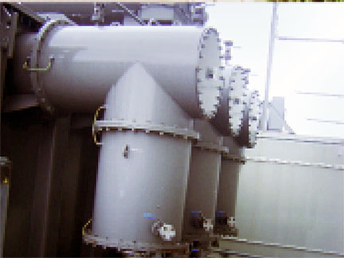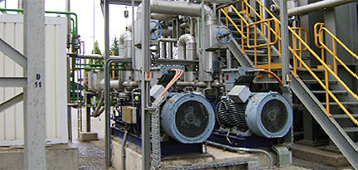
SUMMARY
INTEGRATED PLANT
(DESIGN SPECIFICATION)
Net electrical power: (MW) 125,4 Net electrical efficiency: (%) 51 Ambient temperature: (oC) 18 Air pressure: (mbar) 990
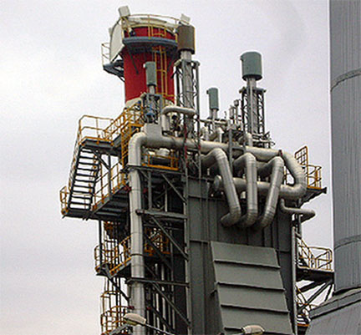
FULL LOAD DATA FOR COMBINED CYCLE
Steam turbine power: (MW) 40,8 Gas turbine power: (MW) 2 x 42,3 Gas turbine - type Frame 6C Gross combined cycle power output (MW) 125,4
Auxiliaries: (MW) 5,4 Net power output: (MW) 120 Net efficiency: 51
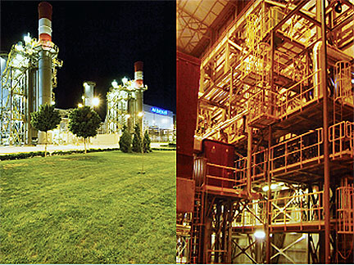
REFERENCE CONDITION
Air intake temperature: (0C) 18 Relative humidity: (%) 55 Barometric pressure: (mBar)990 Fuel: Natural Gas
Backup fuel: Distillate oil
GAS TURBINE
Manufacturer: General Electric Type: Frame 6C Production: (Mwe) 2 x 42,3 Pressure ratio:1/16,4
Flow rate: (Ib./sec) 110 Turbine speed: (rpm) 7100 Exhaust gas temperature:(oC) 600 Specific consumption: (Sm3/Mwh) 310
GAS TURBINE GENERATOR
Manufacturer: VATEC-ELIN Type: 2Poles 3Phase WYE CONN 50 Hz Output: (MVAR) 39 Voltage: (kV) 11,5 Power factor: (cos Æ) 0,8
STEAM TURBINE
Manufacturer: GE Type: Vacumend Production: (Mwe) 40,8 Entry Pressure: (bar) 56 Outlet Temperature: (C) 48 Turbine Speed: (rpm) 3000
STEAM TURBINE GENERATOR
Manufacturer: VATEC-ELIN Type: OLES 3Phase WYE CONN 50 Hz Output: (MVAR) 40 Voltage: (kV) 11,5 Power factor: (Cos Æ) 0,8
HEAT RECOVERY STEAM GENERATOR
Manufacturer: NEM Type: horizontal Pressure in stages (bar) HP: 58;LP: 5 Gas Temperature Entry (oC) 598 Gas Temperature Exit (oC) 102 Production of steam: (t/h) 65
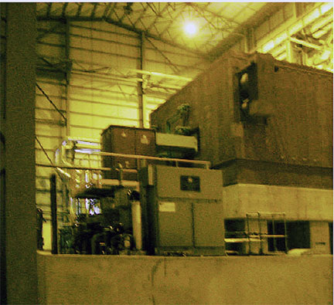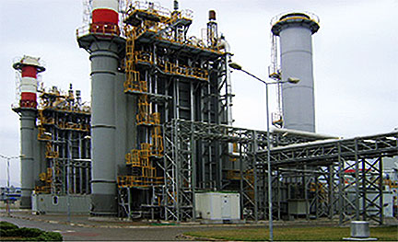

MAINTENANCE
CSA with General Electric for main machines, maintenance schedules as per O&M manuals in terms of scope and periodicity. All as built drawings, performance data and manuals are available.
