 | CFAS Enterprises Inc.  After Market Utility Power Equipment Brokerage  Mailto:Staff@CFASPower.com  Turbine URL: http://CFASPower.com/Inventory.html  Reciprocating URL: http://CFASPower.com/Recips.html
GTG_1734_2xFm9FA_PBks_50Hz.doc

2 x GE 9FA 240MW 2 x CMI HRSG 2 x 144MW Alstom STG Power Islands

768 Mw CC, Natural Gas fired Power Plant 2 x 384 MW Power Blocks
Have Operated under partial load for 4 months ONLY.

Asking Price: US $336MM

2 x 405.4Mw GE FM9FA Power Blocks 50Hz Natural Gas CC - 768Mw Power Plant

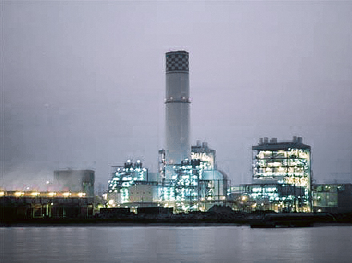

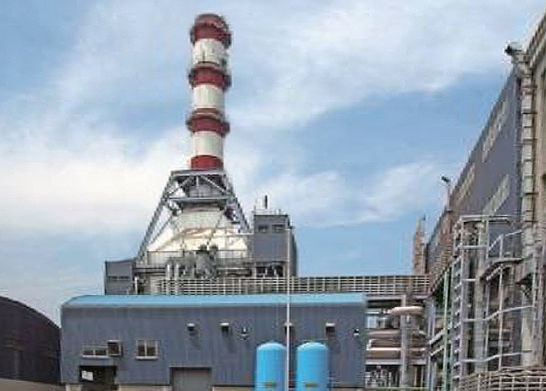

Natural gas based combined cycle power plant
Combined cycle power plant having 2 Blocks with net capacity of 768MW

Asset Overview:
The project consists of Natural Gas Based Combined Cycle Power Plant having 2 Blocks of 405.4* MW (* Performance at ISO Conditions).
Each Power block consists of:
1 no. Frame 9 FA GE make Gas Turbine, Capacity
1 no. Triple Pressure CMI design HRSG.
1 no. Alstom make Steam Turbine.
The total requirement of natural gas is about 3.14 mmscmd at 85% PLF.

Key Performance Parameters
Auxiliary Power Consumption less than 3% for both the Blocks together.
The total fresh water requirement is approx. 21744 CVi- m P^r day. (9 Cusecs)
Power is generated at 15.75 kV at the generator terminal, which is then stepped up to 400 kV for the purpose of transmission.

EQUIPMENT DESCRIPTION

1.Gas Turbine

Model: GE 9FA+e
Rating: 240 MW ISO
Hz: 50
Fuel: Natural Gas
Starting Mechanism: Load Communicated Inverter (LCI)
Configuration: Axial flow, single shaft, two bearings
Air Filtration: Self - Cleaning
Inlet Air Cooling: Evaporative Cooler
Compressor Cleaning: On line and Off line water wash
Emissions Control: (DLN) Dry Low Nox
*Hear Rate in Combine Cycle: 6,350 Btu/Kw
Net Plant Efficiency: 56.7%
Compressor
On-line and Off-line Water Wash Cleaning

** Actual Heat Rate and Net Plant Efficiency is always site conditions and equipment specific.

2.Exhaust System
Exhaust Diffuser w/Expansion Joint for Axial Exit
Emissions Control: DryLowNOx

3.Gas Turbine-Generator(s)

Mfg: GE
Quantity: (2)
Type: 324
Rating: 261.65Mw
Hz: 50
Cooling: Hydrogen
PF: 80 Lagging to .95 Leading
Kv: 15.75
Excitation: Digital Static Bus Fed
Terminal Voltage 15.75KV
Generator Excitation; Digital Static Bus Fed

4.Steam Turbine(s)

Quantity: (2)
MFG: Alstom, Germany
Model: HD1CK + MDG 160/NE37AA
Rating: 169.65 MVA/144.199 Mw
Frequency: 50 Hz
Power Factor (pf): 0.85 Lagging
Terminal Voltage: 15.75KV
Type: Full condensing, single shaft, two casing
Governing System: Electro – Hydraulic
Steam Flow: 105.2 kg/s
Steam Pressures: Matches Boilers
Steam Temperatures: 565.5 / 566 / 277.6 deg C

4a.Main Steam Parameters

HP Steam: 82.4 kg/s ,141 Bar568 Deg C -
IP Steam: 94.3 kg/s @ 34 Bar, 568 Deg C
LP Steam: 9.2 kg/s @ 4.4 Bar, 287.4 Deg C

5.STG-Generators

Quantity: 2
MFG: Supplied by Alstom
Rating: 141.28 Mw
Hz: 50
Cooling: Air
PF: 80 Lagging to .95 Leading
Kv: 15.75
Excitation: Assuming Digital Static

6.HRSG(S)

Quantity: 2
MFG: CMI, Belgium
Orientation: Vertical, Natural draft
Supplemental Firing: Inline

6a.Steam Pressure Conditions

Triple Pressure HP IP LP
Steam Generation, kg/sec: 82.377 94.25 9.18
Steam Pressures, bar (a): 141.01 33.95 4.37
Steam Temperatures, °C: 567.5 568 287.4

7.Balance of Plant

Gas conditioning skids
400 Kv Switch Yard
Building and bridge cranes
Drawings, engineering specifications should be included.

New Equipment Required On Relocation

- Gas Turbine Generator and Auxiliaries GTG and Auxiliaries foundations GTG Building (low bay generator)
- Foundation embedments
- Duct, piping supports and platforms
- Water Wash Skid complete
- EOT crane and Electrical and I&C Cabling
- Steam Turbine Generator and Auxiliaries
- STG and Auxiliaries foundations STG Building Qow bay generator)
- Foundation embedments
- Duct, piping supports and platforms
- Insulation & Cladding
- Electrical and I&C Cabling Heat Recovery Steam Generator and Auxiliaries
- Heat Recovery steam Generator Structures
- HRSG and Auxiliaries foundations
- Foundation embedments
- Piping supports and platforms
- Insulation & Cladding
- Electrical and I&C Cabling
- Common Systems
- Additional NB350mm Alloy steel piping for high pressure steam system
- Additional NB6oomm Alloy steel piping for cold and hot reheat steam system
- Pipe rack and supports
- Extra feed water system & Closed Cooling Water System Extra Condensate System & Circulating Water System Gas conditioning skid Module —I
- Instrumentation & Controls & Miscellaneous
- Instrumentation as required for final relocation plant integration
- Electrical and Control Cabling
- Switchyard & Interfaces
- Mechanical, Electrical and I&C items/equipment/systems as per the re-engineered plant at new location
- Plant other facilities (Roads, drains, non-technical buildings, workshops, public address systems, emission monitorings systems etc)

