 | CFAS Enterprises Inc.  After Market Utility Power Equipment Brokerage  Mailto:Staff@CFASPower.com  Turbine URL: http://CFASPower.com/Index.html  Reciprocating URL: http://CFASPower.com/Recips.html
GTG_1733PW_LM6000_220MwBarge_50Hz.doc

1 x (4 x LM6000PC Sprint) Combined Cycle 220Mw Barge Mounted Power Plant

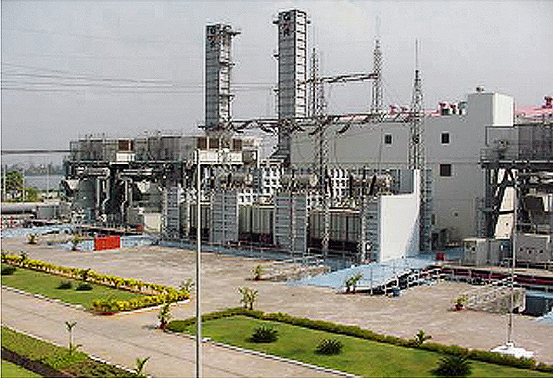

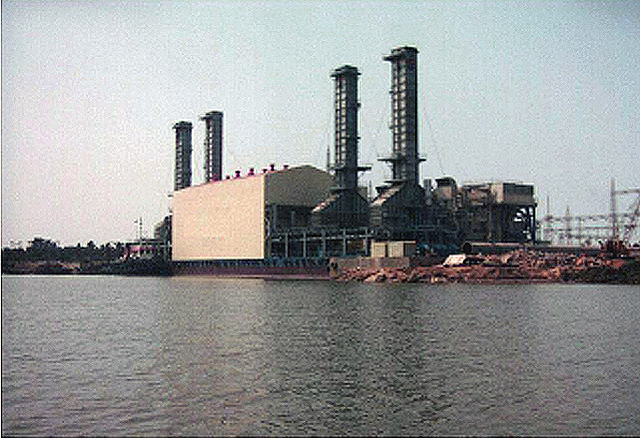

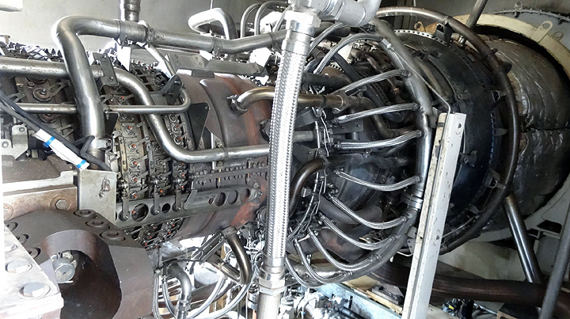

1(4) x GE LM6000 PC Sprint Gas Turbine

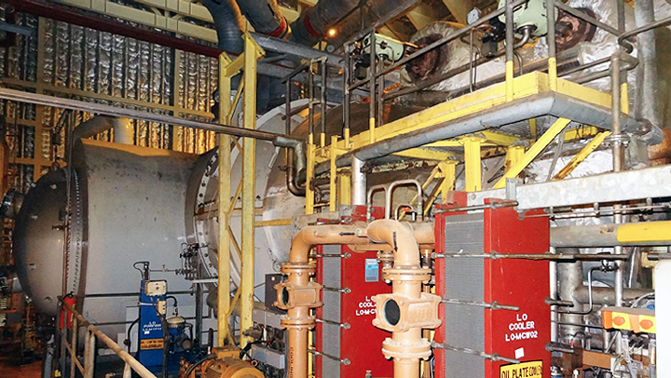

Steam Turbine Generator

**Asking Price: Negotiable

Manufactured

Overview:
Fuel: Natural Gas
Daily Fresh Water Requirement: 1000 cu. m per day at full load
** The gas turbines, OTSG's, steam turbine and their auxiliaries are all mounted on a single floating barge.
The barge mounted combined cycle power plant has;

- 4 nos. 47 MW- LM6000 PC Sprint aero derivative gas turbines

- 4 nos. Once Through Steam Generators.

- 1 no 53 MW⁷ rated output steam turbine and generator.

- Switchyard for Power Evacuation, 415V MCC for DM Plant etc.

- Fuel treatment and forwarding

- Water Treatment Plant and DM plant

- Fire Fighting System

Capacity: 220 MW
Plant Heat Rate: 1950 kcal/kWh on GCV basis (Combined cycle mode)
Barge Size: 106 * 55.2 * 6 m
Barge Weight: 13,000 Tonnes
Barge Normal Draft: 3.4 Meters
Gas Turbine: Make- GE, Capacity- 46.64 MW
Steam Turbine: Make- ABB, Capacity- 53.58 MW

Equipment Description
Gas Turbine (Installed on Barge)

Make GE
Model LM 6000 PC Sprint
Capacity 46.64 MW
Gas turbine Generator is open air-cooled, synchronous type and totally enclosed
5 Stage Low Pressure Compressor - Compression ratio is 2.4:1,
14 Stage High Pressure Compressor - Compression ratio is 12.5:1
Steam Turbine (Installed on Barge)
Make ABB
Capacity 53.58 MW
40 Stage Dual Pressure Condensing type Steam Turbine
2 Pole Generator with air-cooling for Stator & Rotor winding
Compressed Air System

3 x i00% Screw Type Air Compressors with 2 x 100% desiccant type dryers
Capacity: 12.7 Nm3/min and 8.64 bar g discharge pressure

Once through Steam Generator
Make 1ST Canada
Steam Parameter Pressure/ Temperature
HP Steam 59.6 bar / 419 Deg C
LP Steam 4.7 bar / 240 Deg C
Capacity 46.64 MW

Dual Pressure OTSG installed at the exhaust of the Gas Turbine Dry Running Capability
Chillers

Used for Cooling the Gas turbine intake air for increasing the Gas turbine output

2 nos /machine w/Inlet Temp: 7.1 Deg C

Chiller Capacity: 1210 TR

**On shore BOP supplies water to Nox spray, Sprint flow and any make up requirement. About 60 m cube/hr of DM water is required.

The condensate of atmospheric air (form GT Air chillers) is recycled to DM plant as input to minimize water requirements.

Plant Electrical system (Barge Mounted)

Rating: 11KV Evacuated @ 220 KV

2 Nos. Step-up transformer: 11KV /220KV

- 1 each for 2 Gas turbines

- 1 Step-up transformer for Steam turbine

- 2 Nos. of Unit Auxiliary transformers

- Stepping down from 11KV to 6.6 KV for running Plant auxiliaries 4 Nos. of Step-down transformers called Auxiliary Transformers for stepping down the 6.6KV to 415 V

Other Plant Facilities

Demineralization Plant: Demineralization plant (DM plant) produces de-mineralized water for generating steam in OTSG.

Cooling Water System: Cooling Water System suitable for river/sea water.
which can be connected to Closed Circuit Cooling \ Water system onshore if required.

Not Included

Circulating Water system, service water, DM water & fuel

Normal start up power and power evacuation facilities

On shore Balance of plant facilities to be decided based on local environmental requirements Plant capable of black start, but for routine starts separate power is preferred

History

Year if Manufacture

Barge: 2000
GT: 1999/2000 and one more GT 2004 which is in Unit #1 now.
ST: 2000

Fired hours

GT#1; 26376
GT#2: 33127
GT #3: 36913.7
GT #4: 33946.1
STG: 50618

The GTs are under LTSA.

The plant earlier operated on liquid fuel but is now configured to operate on natural gas only. Due to non -availability of gas the plant is under shutdown.

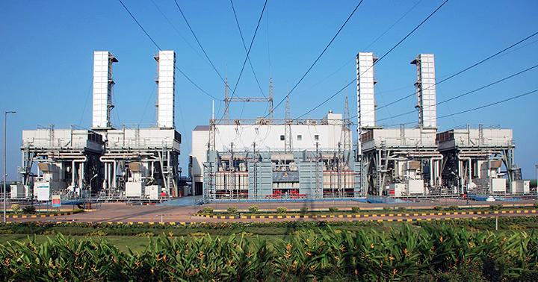

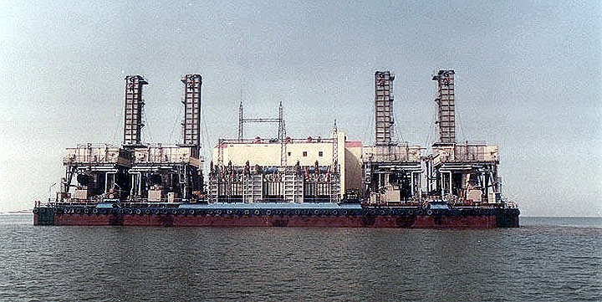

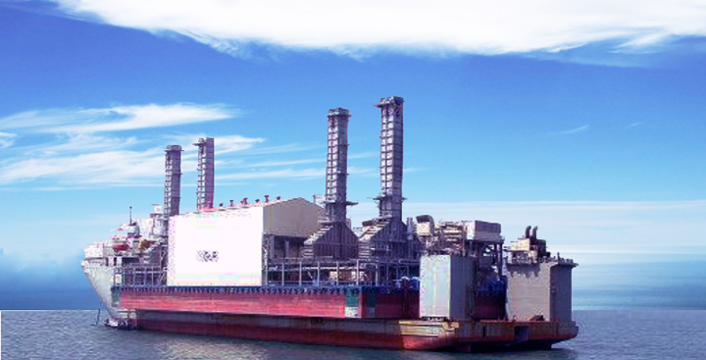

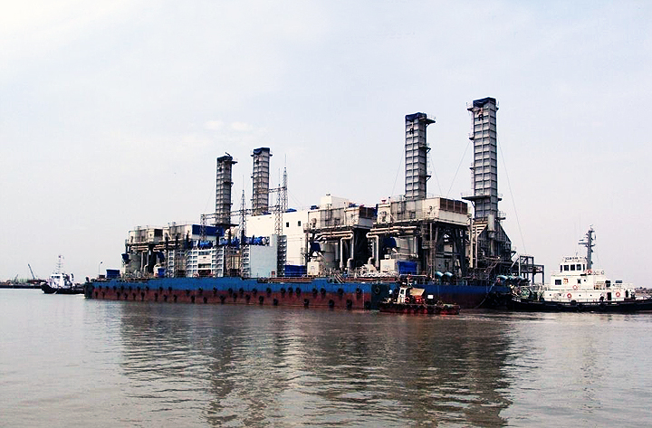

Up Loaded On mother Vessel and Being Transported to Mooring Local

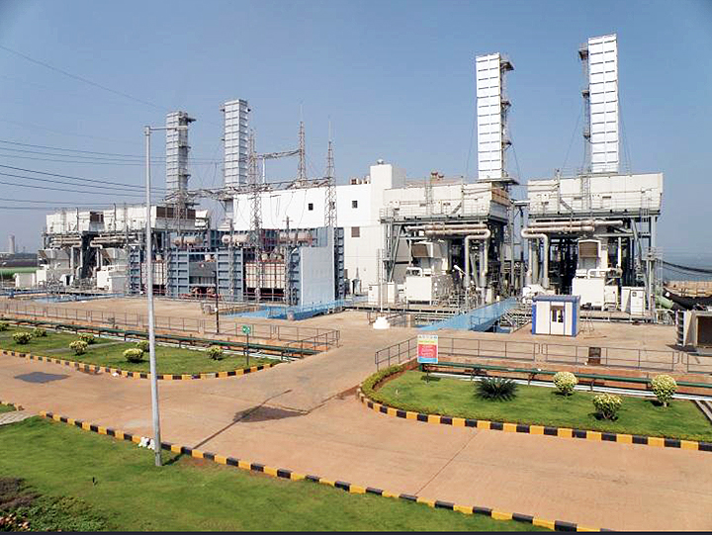

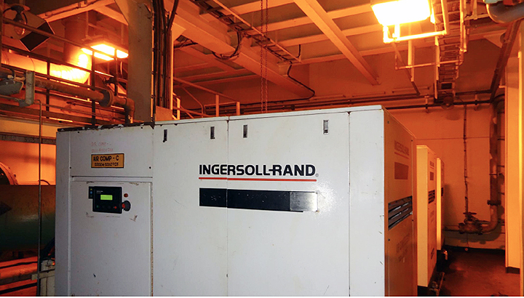

Air Compressors

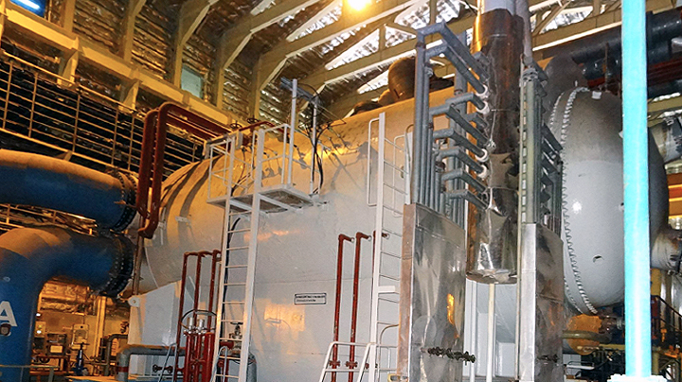

Steam Condenser

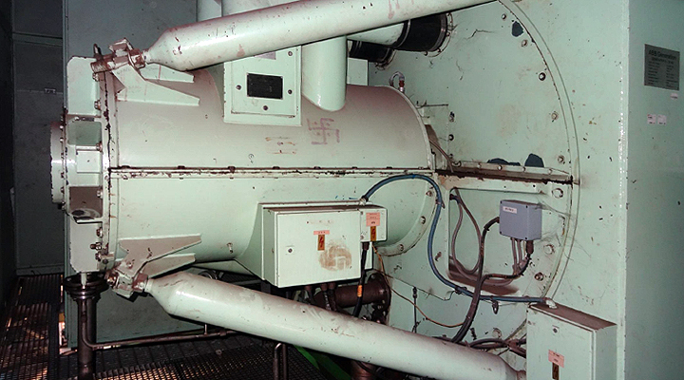

Steam Turbine Generator

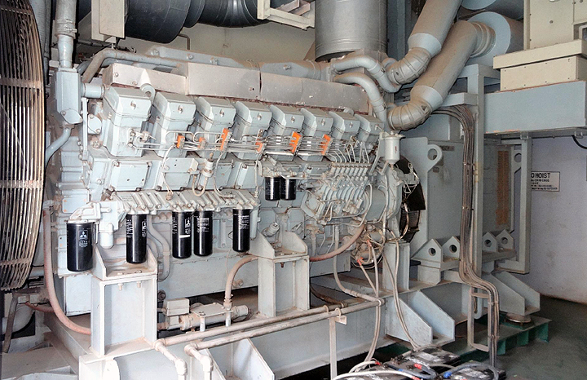

Black Start Generator

