 | CFAS Enterprises Inc.  After Market Utility Power Equipment Brokerage  Mailto:Staff@CFASPower.com  Turbine URL: http://CFASPower.com/  Reciprocating URL: http://CFASPower.com/Recips.html
GTG_1732SRH_SGT5_4000FCC_50Hz.doc

Three (3) Siemens SGT5-4000F 1308 MW Combined Cycle Power Plant

The Standby Power Plant Only Has Test Hours In Operation

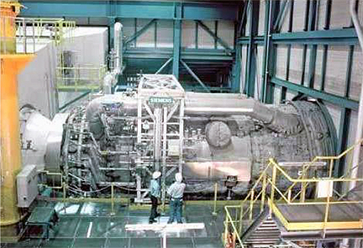

- The power plant has 3 Siemens SGT5-4000F Gas Turbines 1 X Heat Recovery Steam Generator X 1 x Steam Turbine Generator. The Siemens SGT5-4000F gas turbines were manufactured in 1988.

- Quick facts: In Oct 2000, RWE "retired" the plant after the company was unable to resolve licensing conflicts with public and regional authorities. Planning for the DM7bn project began in the early 1970s, it was permitted in 1973, and construction started in 1975. The plant was licensed for operation in Mar 1986 and shutdown

- Power plant is dismantled and reserved by Alstom, and being stored in two European ports and ready for shipping

Asking Price: FOB price USD $30,000,000

Plant’s History

This plant was the power station for the “Mülheim-Kärlich Nuclear Reactor” which has operated for 13 months only. This plant was a stand-by power station.

Technical Info

Siemens SGT5-4000F turbines data:
Model: SGT5-4000F
No. of CTs: 3
Frequency: 50 Hz
Gross / net power output (MW): 292/248 Each
Efficiency / net efficiency (%): 39.8 / 39.5
Exhaust temperature (C): 577-580
Mass flow exhausted kg /s: 688-692
Pressure ratio of: 18.2
KVA: 334,000
PF: 0.85
Voltage (V) line to line: 20000
Speed (rpm): 3000

Download Siemens SGT5-4000F OEM Brochure for Stats

