 | CFAS Enterprises Inc.  After Market Utility Power Equipment Brokerage  Mailto:Staff@CFASPower.com  Turbine URL: http://CFASPower.com/Index.html  Reciprocating URL: http://CFASPower.com/Recips.html
GTG_1729JC_ABB_STG_60HZ.doc

1 x “0” 25.5Mw 60Hz ABB Steam Turbine, Generator & Auxiliaries

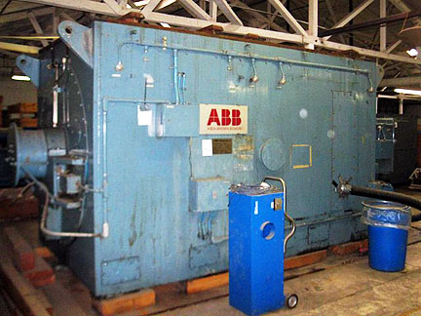

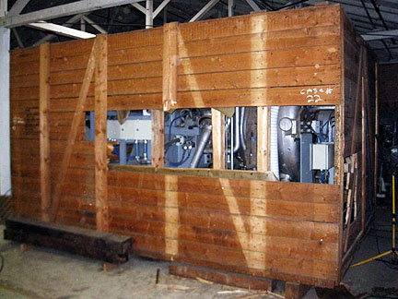

***Offer Includes Steam Turbine / Generator and Auxiliaries as well such as lube oil system, hydraulic oil system, controls, pumps, motors, electrical, etc.

***Generator unit has ZERO hours back up spare that ended up never being put into operation.

Asking Price: US $2.85MM

STEAM TURBINE ABB VAX with Steam Bypass
Operates @: 1474 psia, 951°f, 231 klb/hr
Speed: 3600 RPM
YOM: 1989

GENERATOR ABB Generation
Phase/Hz: 3 ~ 60 Hz
Type: GTL 1050 EA
S/N No. 7253 228
Rating: 31930 kVA / 25544Kw
Speed: 3600 rpm
Voltage: 13110-14490 v
Exc. 80 V 1335 A
Temp.Class: Stator B, Rotor B
Insul. Class: Stator F, Rotor F
ANSI C50.13-1977
YOM: 1989

