 | CFAS Enterprises Inc.  After Market Utility Power Equipment Brokerage  Mailto:Staff@CFASPower.com  Turbine URL: http://CFASPower.com/Index.html  Reciprocating URL: http://CFASPower.com/Recips.html
GTG_1721SW_SGT700_NG50Hz.doc

1 x Unused Siemens SGT-700 32.82MW 50Hz or 60Hz NG Power Plants

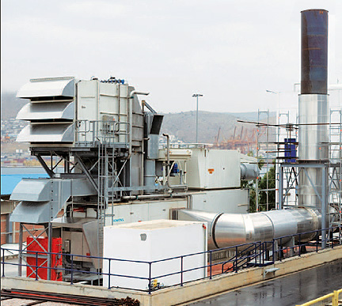

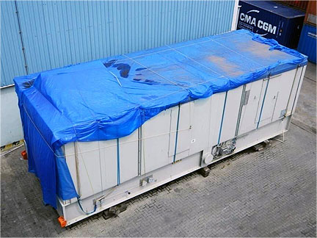

Asking Price: US $18MM

SGT-700 Turbine Generator

Year of manufacture: 2011
Power generation: 32.82MW(e)
Fuel: Dual, Nat gas/High Speed Diesel (HSD)
Frequency: 50HZ
Rated voltage: 11 kV
Electrical efficiency: 37.2%
Heat rate Gas: 9,675kJ/kWh (9,170BtinkWh)
- Heat Rate HSD: 10854 kJ/ kWh @ 24.74 Mwe at 35°C amb.
Turbine speed: 6,500rpm
Compressor pressure ratio: 18.7:1
Exhaust gas flow: 95.Okg/s (209.4lbJs)
Exhaust temperature: 533°C (991"F)
NOx emissions (with DLE, corrected to 15%0₃dry): <15ppmV

Electric Generator Equipment
Electric Generator (ABB make)
Four pole (salient) three phase synchronous generator with the following equipment:
- Brushless AC- exciter with rotating rectifier and PMG for excitation power supply
- Insulation stator and exciter, class F, Insulation main rotor, class H, with a temperature rise at gas turbine rated output and power factor 0,8 within class B absolute according to' 16.3.4 of IEC 34-1 within the ambient temperature range.
- Temperature monitoring by RTD and vibration monitoring by accelerometers.
- Line and neutral side termination point for MV terminal enclosure.
- Anti condensation heater in the main machine, exciter and MV terminal box.
- Separate junction boxes for instruments, excitation and heaters.
- Rated Current, Max FLC (Full load Current) and short circuit current, peak 10OkA.

Generator type: AMS 1250SE.
Frequency/Speed/Voltage: 50 Hz /1500 RPM /11 kV.
Rated Power: 40000 kVA at 35°C cooling water temperature
PF: 0,8.
Generator cooling: IC8 A1W7 (TEWAC).
Four top mounted cooler elements (2+2) and heat exchangers with single tube material.
Spares: List to be provided.

Location: Warehouse, Chennai, India
Condition: Well preserved as per Siemens storage instructions, in packed condition as received from Siemens. Gas Turbine, Generator, Control Room and Batteries in separate enclosed containers
Number of packages: 52 Nos (Main package) plus equipment lifting tools and tackles
Lifting tools and tackles on returnable basis to Siemens, Sweden
Delivery: On ‘as is, where is basis’ from the Chennai warehouse
Customs clearance for export shall be obtained by present Owners
Warranty: Currently not available. To be taken up with Siemens directly
Installation and commissioning: To be taken up with Siemens directly on daily man-day rate basis

Download Scope of Supply

Download Layout Drawing

Download SGT-700_Broch.pdf

