 | CFAS Enterprises Inc.  After Market Utility Power Equipment Brokerage  Mailto:Staff@CFASPower.com  Turbine URL: http://CFASPower.com/Index.html  Reciprocating URL: http://CFASPower.com/Recips.html
GTG_1718MML_CentraxCHP_50Hz.doc

1 x Unused Centrax CX501-KB7 50Hz 6.3Mw NG CHP Plant

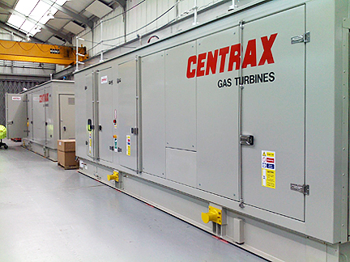

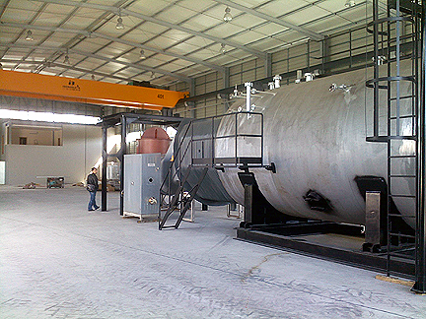

Asking price is: 2.65 MM Euros
Never Installed

Download CT Scope of Supply

Download HRSG Scope of Supply

Download Performance Data Sheet

Download Cogenerator Drawing

Scope is: Gas Turbine and Heat Recovery Boiler.
The plant was planned to be coupled with a Heat Recovery Steam Generator HRSG) but, the plant is never installed.
All equipment is warehouse preserved.

TECHNICAL SPECIFICATION

Capacity: 5065 kWe
Type: CX501 KB7 Rolls Royce
Packager: Centrax
Type of Alternator: Brushless
Frequency: 50 Hz
Revolution: 1500 rpm
Alternator Output:6300 V
Fuel types: Natural Gas
Year of Commissioning: Never installed and commissioned
Total Plant: 0
Major Overhaul: Never operated
Status: Available for sale

CENTRAX CX501 KB7 Gas Turbine Cogeneration Plant - Details
Saturated Steam pressure: 10 barg
Nominal Boiler Output (unfired): 12 t/h
Nominal Boiler Output (fired): 20 t/h

The system includes one post-combustion natural gas burner (ECLIPSE)

