 | CFAS Enterprises Inc.  After Market Utility Power Equipment Brokerage  Mailto:Staff@CFASPower.com  Turbine URL: http://CFASPower.com/Index.html  Reciprocating URL: http://CFASPower.com/Recips.html
GTG_1717EM_SGT800_60_50Hz.doc

3 x New Siemens SGT-800 50Hz/60Hz 47.5Mw DF Gas Turbine generator Packages

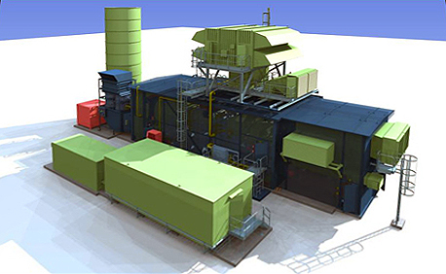

Asking Price: US $27.9 FOB Sweden
**Includes Full 1 Yr./8000 Hr. OEM Warrantee

Power output: ISO 47.5 MW(e)

Fuel: Natural gas/other gases within specs / Diesel no2

Power output: ISO 50.5 MW(e)
Fuel: Natural gas/other gases within specs / Diesel no2

Frequency: 50/60 Hz

Voltage: 11kv @ 50Hz / 13.8KV @ 60Hz

Electrical efficiency: 37.7% 38.3%

Heat rate: 9.557 KJ/kWh 9.407 kJ/kWh
(9.058 Btu/kWh) (8.916 Btu/kWh)

Turbine speed: 6,608 rpm 6.608 rpm

Compressor pressure ratio : 20.4:1 21.1:1

Exhaust gas flow: 132.8 kg/s (292.8 Ib/s) 134.2 kg/s (295.8 Ib/s)

Exhaust temperature 54rC(10069F) 553'C (10278F)

NOx Emissions (with
DLE, corrected to 5%02dry): 15ppmV 15ppmV

Download Scope Of Supply

Download OEM Brochure

