 | CFAS Enterprises Inc.  After Market Utility Power Equipment Brokerage  Mailto:Staff@CFASPower.com  Turbine URL: http://CFASPower.com/Inventory.html  Reciprocating URL: http://CFASPower.com/Recips.html
GTG_1711GLR_W251AA_60Hz.doc

Four (4) Use Westinghouse 251AA 24mw 60Hz DF Gas Turbine Generator

Gas Turbine Specifications
Manufacturer: Westinghouse
Model: 251AA
Power Rating (kW): 24,000
Fuel Configuration: Natural Gas / Fuel Oil
Starting System: Cummings Diesel Black Start System
Average Operating Hours: 15,000 Lifetime
Average Number of Starts: 3,800 Lifetime
Acoustic Enclosures: Yes
OEM Manuals & Drawings: Included
Year: 1971

Generator Specifications
Manufacturer: Westinghouse
Model: 110P718H01
Hertz: 60
KVA: 28,000
Power Factor: 0.85
Volts: 13,800

Asking Price: US $700,000 Each

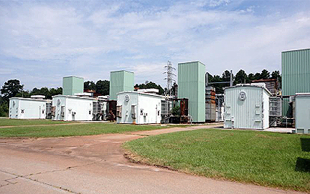
Four (4) Westinghouse Gas Turbine Generators – Forward View

• New Exhaust Plenum & Ductwork Completed in Late-1980’s
• Cable & Wiring Diag. Included • P&ID & OEM Operations & Maintenance Manuals Included
• High Voltage Buss & Transformers Available
• Operation & Maintenance History Available
• Operable Condition
• Fluids Drained July 2013
• Sold as “Loaded on Buyers Transport” at Original Installation Site

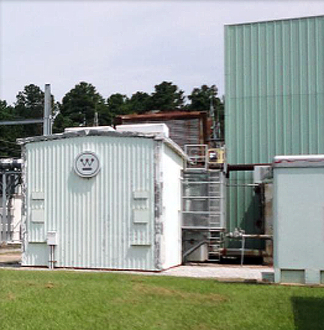
Four (4) Westinghouse Gas Turbine Generators Forward View of One Unit

