 | CFAS Enterprises Inc.  After Market Utility Power Equipment Brokerage  Mailto:Staff@CFASPower.com  Turbine URL: http://CFASPower.com/Index.html  Reciprocating URL: http://CFASPower.com/Recips.html
GTG_1704TSI_FT4TP_60Hz.doc

1 x Used Pratt & Whitney FT4A-9 45.6Mw 60Hz DF Modular Industrial Twin Pack

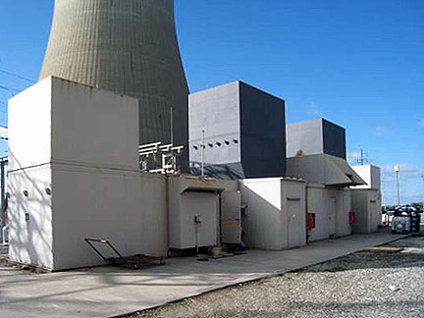

Asking Price: US $4.9MM for complete package (where is / as is)

Commissioned in 1970 at a facility in SE, USA
Both engines underwent a depot visit in 1999.
Available for removal no later than May 1, 2013
The generator and control house are currently 60hz, but conversions to 50hz is possible
Additional information will be provided upon receipt of letter of intent from potential buyers. A site visit and boroscope inspection of the unit can be arranged.

Manufacturer: Pratt &Whitney
Model: FT4A-9
Operation: Continuous
Fuel: Dual Fuel (Diesel/Nat Gas)
Turbine Design: Open cycle, single shaft, cold-end drive
Compressor: 15 Stage axial
Power Turbine: 2 Stage axial
Rating: 45.6Mw
Voltage: 11Kv
Frequency: 60Hz
Heat Rate: 12,500 BTU/ KwH
Power Factor: 0.85
Phase: 3 phase
Speed: 3600 RPM
Direction of Rotation
Total Fired hours unit: TBD (last known at this time 8,789 in 1999)
Total starts unit A: TBD
Total fired hours unit B: TBD (last known at this time 8,806 in 1999)
Total starts unit B: TBD

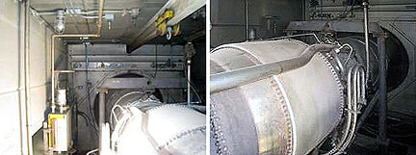

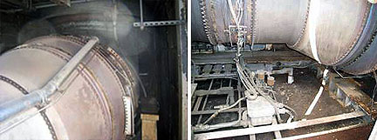

Generator
Generator Remanufactured: Electric Machinery
Maximum power: 46.5 MVA
Voltage: 11000v
Phase: 3 phase
Power Factor: 0.85
Poles: 2 pole
Hertz: 60 Hz
Speed: 3600 R.P.M
Bearing: Two-Bearing Gem
Cooling: Air-cooled
Total EFF: 80%

The Plant Consists Of Two Units Each:
1-Gas turbine
2-Power generator
3-Auxilaries systems
4-Control

1. Gas Turbine
Gas generator and power turbine: GG4A-9-FT4A-9
The (GG4A) Gas Generator consists of:
• Inlet nose cone
• Inlet bell mouth
• Compress. Inlet Gas
• Low press. Compressor Assembly
• Main Gear box
• Diffuser case

1.1 Turbine Assembly
Exhaust case
Free Power Turbine
• Free Turbine Inlet case
• Free Turbine Rotor Assembly
• Free Turbine Exhaust case

2. Power Generator
Power: 46.5 MVA
Volt: 11000v

3. Auxiliaries systems
Lube oil system
• Cooling water system
• Gas fuel system
• Liquid fuel system
• Filter system
• DC/AC pumps
• Fire protection system
• Air start Pac system
• Excitation system

4. Controls
• OEM sequencer, all interfaced with the balance of controls, voltage regulator, unit alarm and trip switches, synchronizing, etc.
• All necessary generator protective (G P U)
• Volt /WATT / VAR /frequency meters
• Gas turbine tachometers, turbine speed control, breaker switch And status lights
• Local /Remote selection

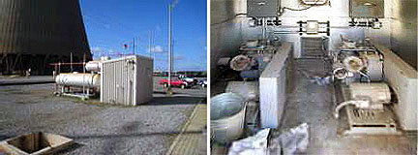

SCOPE OF SUPPLY - Twin PAC -
The FT4 Twin Pac consists of three primary units - one gas turbine unit, the generator unit and the control unit. The turbine and generator units are comprised of two (2) opposed Gas Turbines directly connected, through diaphragm couplings, to a electric generator with a through-drive connected brushless exciter. The control unit is located adjacent to the turbine/generator enclosure and contains all of the controls and instruments necessary to operate the generating plant. The turbine/generator and control units are housed in all-weather painted steel enclosures, which include light and fire protection equipment. The inlet silencers and exhaust stack have an all-weather painted steel-exterior. Typically an entire plant occupies approximately 136’ x 32’ of space with the turbine generator module commonly erected on a 102’ x 20’ reinforced concrete pad. The Twin Pac as erected on site, is ready for installation on concrete foundations, connection to main step-up transformer or bus and a fuel supply system - as supplied by the Purchaser.

BILL OF MATERIAL
This Bill of Material represents one complete Twin Pac Generating set and consists of the following major elements as noted below:
• Two Modular Industrial Gas Generators
Pratt & Whitney FT4A-9 dual fuel fired
• Two Industrial Power Turbines
• 60 Hz EM Generator
46.5MW
• Base Plate including mounts and couplings
• Bentley 3300 Vibration Monitoring System
• Air Starting System
Two Ingersoll Rand 15T2 Compressors skid mounted to provide starting air (three starts) to the gas generator pneumatic turbine starter. Includes compressor, starting regulator, pressure controls, air receiver and enclosure, suitable for outdoor mounting on concrete foundation.
• Fire Protection System
Fike 107 gallon MicroMist Water Spray Suppression System
• Lube Oil System
• Ventilation System
• AC lighting
• Propane Emergency Start System
• Fuel Forwarding Skid
• Acoustic Enclosure
• Control House
OEM sequencer, voltage regulator, unit alarm and trip switches, sequencing,
synchronizing, etc., all pre-wired to ensure safe operation. Pre-fabricated painted steel
enclosure including air conditioning, interior lighting, 125 VDC emergency lighting
system. All necessary generator protections, volt/watt/VAR/frequency meters & switches, gas turbine tachometers, turbine speed control, breaker switch, synchronizer,
sequence/status lights, local/remote selection, engine instrument rack, master terminal
board, CTs/PTs, MCC, auxiliary transformer, air circuit breaker etc. Bus duct from
generator output terminals to the switchgear cubical
• Complete Switchgear line up
• Service manuals, in the English Language, for all major systems including specific
operating instructions.

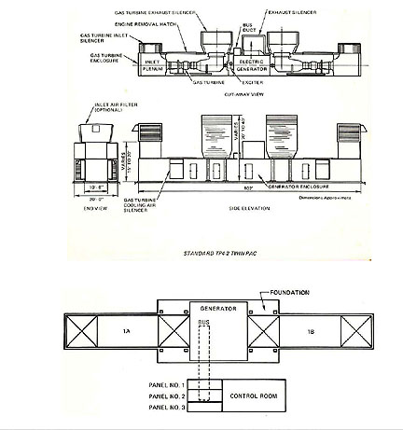
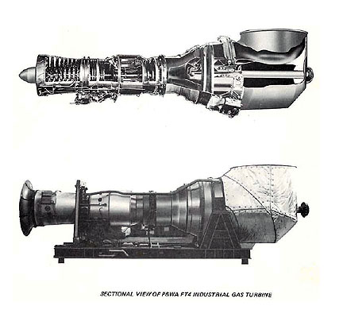

PERFORMANCE

GAS TURBINE
A. GAS TURBINE
1. Characteristics

a. Engineering Data
Controlling Specification: Reference P&WA No, 6220

Type: A multi-stage reaction turbine driven by hot gases: from an axial-flow generator, consisting of multi-stage compressors driven by multi-stage reaction turbines,
Model: FT4A-9 Engine/Twin Pac

Number of Stages:
Gas Generator:
Low-speed compressor: 8
High-speed compressor: 7
Low-speed turbine: 2
High-speed turbine: 1
Power Turbine: 2

b. Service Requirements

Fuel 1: Natural Gas
Specification: FR-2
* Delivery Rate -1000 SCF/Hr. 386
(Max, flow rate during acceleration only
* * Delivery Pressure, at gas turbine- inlet psia: 350 ±5
* Based on a natural gas fuel containing 950 BTU/SCF (LHV) (HHV/LHV=1.11) and delivered to the engine from Purchaser's supply system in a CLEAN and DRY condition (filtered to 30 Microns).

Fuel 2: Liquid Fuel
Specification: FR-1
*** Delivery rate- gph (Max. flow rate during acceleration only) (Est.) - per engine 3565
Delivery Pressure, at gas turbine, psig 5-50
**** Delivery Temperature at gas turbine enclosure, °F Minimum 25
*** Based on a distillate fuel with a density of 6.9 lbs./gal. and LHV of 18,500 BTU/lb.,
(HHV/LHV=1.06), delivered to the engine from
Purchaser's supply system in a CLEAN and VOID
OF FREE WATER condition (below 5 microns solid particles and 0.01% water by weight)
**Cyclic pressure variations can be tolerated so long as total pressure excursion does not exceed +/- 5 psi from average pressure supply.

Lube Oil:
Specification: PWA 521
Consumption: gph (Avg.): 0.1
Total required for complete system: 50 U.S. gals.
Electrical:

Purpose Quantity
Lighting, heating and or 100 KW/engine, 440V, 60 Hz, intermittent power 3 phase per unit
Natural Gas:
1. Gas Turbine Starting: 2625 SCFM per unit at 100 psig minimum for one (1) minute per start.

2. Gas assisted combustion A flow rate of 225 SCFM/unit during start-up for Dual Fuel at a pressure of 235 psig at Configured Engines when the engine manifold operation on distillate fuel. connection, for a period of
forty five (45) seconds per start.

