 | CFAS Enterprises Inc.  After Market Utility Power Equipment Brokerage  Mailto:Staff@CFASPower.com  Turbine URL: http://CFASPower.com/Index.html  Reciprocating URL: http://CFASPower.com/Recips.html
GTG_1697MS_KongKG5_Mob.doc

3 Unused Kongsberg/Viking KG5 3MW 50Hz or 60Hz 2740kW DF Mobil Power Plants

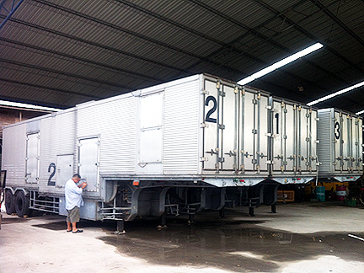

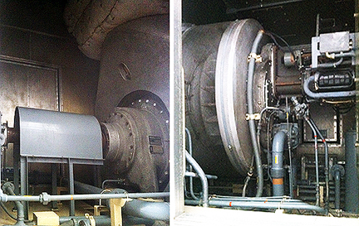

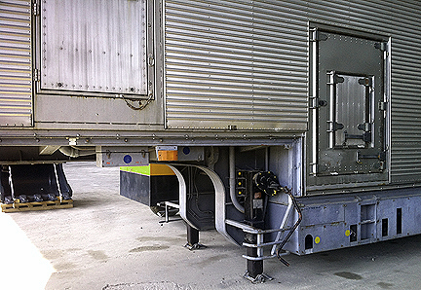

The Turbines were made in 1980 and have never been used requirement change. They are warehouse stored and in brand new condition. The Turbines are configured on trailers with complete set of control panel and alternator by Kobelco.

PRICED TO SELL: US $800,000 ALL 3 - FOB Kuching, Malaysia

Download KG5 Data Sheet

Download KG5 Specifications

Download KG5 Brochure

DESCRIPTION

The KG5 generating set is an industrial type electric power unit comprising an open-cycle, two-shaft gas turbine prime mover and a brushless open-ventilated generator rated to suit the gas turbine characteristics at various ambient conditions. Standard output voltages range from 380 V to 13.8 kV at 50 or 60 hertz.

SPECIFICATION

Output shaft speed: 1500 or 1800rev. min 150.60 Hz) as standard
Gearbox: Epicyclical
Compressor pressure ratio: 6.3:1
Speed control characteristics:
Steady state speed control: Max | 0.25%

TYPICAL ON-SITE PERFORMANCE DATA

(Sea level, 100 mm wg intake loss, 100 mm wg exhaust loss and 96% generator efficiency:
Ambient temp. Max Base Load
15UC (59°F) 3385 kVA 3425 kVA
35°C I95°F) 3340 kVA 2905 kVA
Max Continuous power rating for operation up to 1500 hours per year
Output stated based on power factor: 0.8
Fuel consumption: 1150 kg h (2535 Ib/h) (at 3000 kW. 16°C wi/ diesel fuel)
Heat Rate: 11,747 KJ/KW-HR

** A regenerator can be installed when improved fuel economy is required *or continuous duty applications. Full load thermal efficiency can thus be increased to over 30% (corr to approx. 850 kg h diesel fuel at 3000 kW output).
Lube oil consumption: Approx. 0.07 kg/h (0.15 Ib/h)

STARTING

Starting is achieved by a starter motor connected to the gas generator rotor via a sprag-clutch in the auxiliary gearbox. Starting time to nominal speed with full load applied is 45 to 60 seconds depending on systems selected.

Materials

Component Material
Turbine Wheel: Waspaloy
Compressor wheel: Titanium alloy.
Combustor: Hastalloy X
Turbine Housing: PE 10
Reduction Gear Casing: Silumin
Lube oil Tank Foundation: Mild Steel
Pressure Casing: Coated Mild Steel
Power Turbine: Waspaloy

CORROSION RESISTANCE

The complete generating set is designed for operation in all types of industrial environment and is also approved by the major marine classification societies for use on board ships. Special attention has been paid to corrosion resistance and sleeve bearings are employed to support ail rotating parts in the turbine engine.

DIMENSIONS

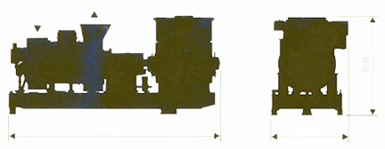
6820 2500 3230

Weight:

Complete generating set with accessories necessary to run (approx.:
21 003 kg 46 000 lb.
Combustor Head Complete: 123 kg 265 lb.
Auxiliary Gear complete: 243 kg 530 lb.
Gas Generator Rotor: 235 kg 5181b
Power Turbine Rotor: 73 kg 167 1b
Main Reduction Gear: 805 kg 1775 1b
Complete GT with Reduction Gear: 376D kg 8290 It)

