 | CFAS Enterprises Inc.  After Market Utility Power Equipment Brokerage  Mailto:Staff@CFASPower.com  Turbine URL: http://CFASPower.com/  Reciprocating URL: http://CFASPower.com/Recips.html
GTG_1693EN_LM2500CHP_50Hz.doc

1 x Used GE LM2500/ABB 24.9 MW 50Hz Nat Gas CHP Power Generation System

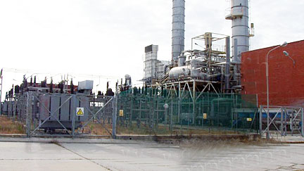

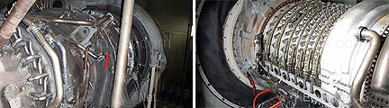

Asking Price: US $5MM

Manufacturer General Electric
Year 1994
Model LM2500
Fuel Type GAS
Recommended Packaging Form CUSTOM
The Complete Cogeneration Unit with a combined nominal capacity of 24.9MW consist of the following:

GE LM2500 Gas Turbine of 21.5MW Capacity

GE LM2500 Gas Turbine
Capacity: 21.5 MW
Maximum Flow Rate: 6300 Nm3/hr
Normal Flow Rate: 5800 Nm3/hr
Nominal Working Pressure: 32 Bar
Volts: 6,3 KV.
Last full overhaul; May 08
HRS SINCE OH’D: 19,500 hrs
Condition. GE does a monthly turbine preservation labor.
Documentation: Available

ABB Backpressure Steam Turbine of 4.5MW Capacity

Last overhaul November 09.
Type: G18A
Turbine speed: 12,000 rpm-reduced to 1500 rpm by set of gears
Turbine Stages: 7
Direction of turbine rotation: CCW
To produce mechanical power the turbine receives superheated steam from the boiler
Deutsche-Babcock Steam Boiler With A Capacity Of 33 Ton/Hr At 61 Bar Pressure

Year: 1994
Year of Modifications (revamping): 2000-2001
Fuel: What is the fuel it burns Natural Gas, or #2 fuel oil or combination. If natural gas is there a gas compressor available. Plant burn natural gas. There is a gas compressor available and all the facilities needed to measure, control and provide gas at different conditions to the gas turbine and post-combustion
Gas Compressor: 10 – 16 to 32 bar.
Control system. TURLOOP of ABB Turbine Nürnberg Gmbh. It is a fully electronic and programmable protection and control system.

ABB Back Pressure Steam Turbine Of 4.5 MW

Spare Parts: Yes
ABB Back pressure steam boiler: Coupled to the generator
Skid Mounted: Yes
Inlet press/temp/exhaust pressure. 60 and 9 bar.
Age and manufacturer: Manufacturer is Alstom. 16.5 years (including 1.6 years since the closure of the factory).
Spare parts: Yes

Babcock Steam Boiler

Boiler pressure/superheated temp: .60 bar and 450 C.
Is the boiler equipped with:
Supplemental burner and what
fuel did it burn: Yes, Post combustion natural gas burner.
Is the boiler a packaged type. Yes
General arrangement drawings. Yes
Does boiler have a national board
number stamping on it as well as
ASME certification: Yes
Spare parts. Yes

Description of Modifications: Re-route the piping lines that come out of the boiler to the superheaters and the factory vapor lines. The actual line coming out of the boiler to the primary superheater was substituted with a line to the final superheater(which became the primary superheater) closer to the evaporator. From the exit of this superheater a line was routed to the former primary heater which became now the final superheater.
Objectives: To facilitate the increase of vapor production from the generator and make it match the new working conditions of the boiler.
Overall Inspection and Recertification Performed on 2010 by ATISAE- agency that regulates the pressure vessels in Europe
Gas Natural Post-Combustion System to produce hot gases for 42 ton/hr of additional steam.
All electrical and control equipment located within the installation perimeter of this system.

