 | CFAS Enterprises Inc.  After Market Utility Power Equipment Brokerage  Mailto:Staff@CFASPower.com  Turbine URL: http://CFASPower.com/  Reciprocating URL: http://CFASPower.com/Recips.html
GTG_1687SC_FT8Mobiles.doc

New Pratt & Whitney FT8 25 MW 50Hz or 60Hz DF Gas Turbine Mobile Generator

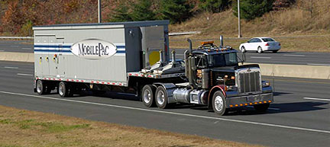

Sale price $18.5MM each

Download Scope of Supply

Download P&W FT8 MobilPac Brochure

Download P&W FT8 MobilPac Fact Sheet

Download P&W FT8 MobilPacs Weights and Dimensions

Download Training Data Document

Download Start-Up Commissioning Support Document

Manufacturer: Pratt & Whitney
Engine Model: FT8
Output (kW): 25000
Noise: 95 dba at 1 meter
NOx/CO: 50/100 mg/m3
Fuel: Liquid or gas
Generator: Brush 62-170.
Voltage=PF: 11.5kV, 0.9PF AND 13.8kV
Frequency: 50Hz or 60Hz

The MOBILEPAC gas turbine package design includes two trailers.

Trailer 1
Gas Turbine
Electric Generator
Exhaust Collector
Diffuser
Engine Lube Oil System

Trailer 2:
15 Kv Switchgear
Control System,
Operation Panel
Protective Relays
Batteries And Charger
Motor Control Center
Hydraulic Start Package

Compared to a typical 21-day installation and commissioning cycle for the
SWIFTPAC gas turbine package, the MOBILEPAC gas turbine package can be driven to a site and begin generating power in less than one day.

Included:

- PW includes 760 man-hours of Technical Advisor Service (Mechanical/Electrical)
- PW includes personnel to support a thermal performance test to prove power output and heat rate guarantees.
- PW includes a 14 days of FT8 Training. This includes modules on Operations, Maintenance and Controls
- PW includes the service of one (1) Electrical Generator Field Representative for unit commissioning

