 | CFAS Enterprises Inc.  After Market Utility Power Equipment Brokerage  Mailto:Staff@CFASPower.com  Turbine URL: http://CFASPower.com/  Reciprocating URL: http://CFASPower.com/Recips.html
GTG_1687RC_FT4Mobiles.doc

4 x New Pratt &Whitney FT4 25 MW 50Hz or 60Hz DF Gas Turbine Mobile Generator

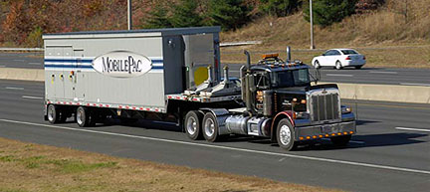

Asking Price: $15.95 MM Each

Download Scope of Supply

Download P&W FT4 MobilPac Brochure

Download P&W FT4 MobilPac Fact Sheet

Manufacturer: Pratt & Whitney
Engine Model: FT4
Output (kW): 25000
Noise: 95 dba at 1 meter
NOx/CO: 50/100 mg/m3
Fuel: Liquid or gas
Generator: Brush 62-170.
Voltage=PF: 11.5kV, 0.9PF AND 13.8kV
Frequency: 50Hz or 60Hz

The MOBILEPAC gas turbine package design includes two trailers.

Trailer 1
Gas Turbine
Electric Generator
Exhaust Collector
Diffuser
Engine Lube Oil System

Trailer 2:
15 Kv Switchgear
Control System,
Operation Panel
Protective Relays
Batteries And Charger
Motor Control Center
Hydraulic Start Package

Compared to a typical 21-day installation and commissioning cycle for the
SWIFTPAC gas turbine package, the MOBILEPAC gas turbine package can be driven to a site and begin generating power in less than one day.

