 | CFAS Enterprises Inc.  After Market Utility Power Equipment Brokerage  Mailto:Staff@CFASPower.com  Turbine URL: http://CFASPower.com/Index.html  Reciprocating URL: http://CFASPower.com/Recips.html
GTG_1685SST_Saturn20.doc

1 x Solar Saturn 20 1096Kw 50Hz 11Kv Natural Gas CHP Generator Set

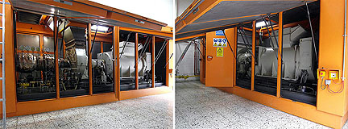

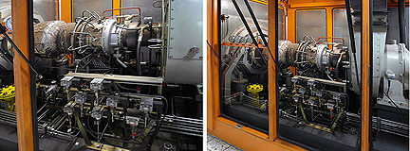

Price: Euro 110.000 Loaded On Customer's Truck
Europe

Solar Saturn 20
\Manufacturer: Solar
Model: Saturn 20
Control system: Woodward
Packaged by: Turbomach
Rating: 1096Kw
Fuel: Natural Gas

Reduction Gear
Type: Epicyclic
Speed; 1500 RPM

Generator
Manufacturer: AVK
Rating: KVA 1370
Volts: 11Kv
Frequency: 50Hz
Phase: 3
Insulation Class: F

Year Manufactured: 1996 (Turbine 2008)
Total hours: Approx. 128,000
Hours since last inspection: 35,000 plus running (after 2008)

HRSG
Manufacturer: Wulff
Model: CE0045
Max Pressure: 10 bar-g
Thermal capacity: 2900Kw
Total Volume: 835
Max temp: 120 degrees C
Test Pressure; 15 bar-g

