
CFAS Enterprises Inc.
After Market Utility Power Equipment Brokerage
Mailto:Staff@CFASPower.com
Turbine URL: http://CFASPower.com/Index.html
Reciprocating URL: http://CFASPower.com/Recips.html
GTG_1684GR_T60_HRSG.doc

1 x 1995 Unused HRSG for Solar T-60 with Ducting & Expansion Joints

Manufactured and imported from US

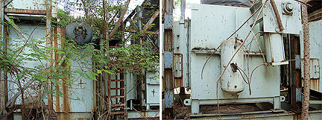

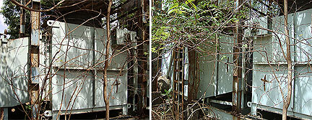

Asking Price: US $175,000 negotiable
The unit has been inspected and is in unused condition except for paint

Manufacturer: Energy Recovery Int’l USA
Model: 2.5-2016
YOM: 1995
SN: W.3396
Sq. Ft: 17.210
PSIG: 300
Lbs. per Hr.: 23,000
Max A.W.P.: 300 PSIG
Max Rated STM Cap.: 23,000

