 | CFAS Enterprises Inc.  After Market Utility Power Equipment Brokerage  Mailto:Staff@CFASPower.com  Turbine URL: http://CFASPower.com/Index.html  Reciprocating URL: http://CFASPower.com/Recips.html
GTG_1673GI_DresserRandSTG_60Hz.doc

1 x (2) Used Dresser Rand 18.68Mw.47Kw 60Hz Steam Turbine Power Plant

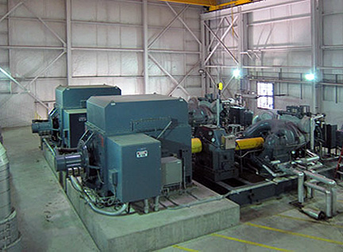

Asking Price: US $4 MM
Can offer removal and loading services

Power Plant - 18.68 MW
1 x Used- Power Plant 18.68 MW Consisting Of: (2) Dresser-Rand 9.341 MW Condensing Steam Turbine Generator Sets.

Year 2009

Dresser item no. MVR
Model: RD6MO-MV (6 stage) condensing turbine.
Phase: 3
Hertz: 60
Voltage: 12,470 V (12.47 KV)
RPM: 4518
PSIG: 175 psig at 515 deg F inlet x 4" HgA exhaust

Hyundai Ideal brushless generator frame 21520-41
Type: SAB
Voltage: 12,470
Phase: 3
Hertz: 60
RPM: 1800
Power Factor: 0.8
Amps: 541
Pressure Lubed Bearings: 15-20 psi 1.9 gpm each
Oil: 215SSU

Hyundai Ideal brushless exciters frame BE-13-3
Type: FRBA
KW Output: 25 180 VDC 139 DCA
Field Voltage: 75
Amps: 3.7

Hyundai Ideal Permanent Magnet Alternators
KW: 2.2
Voltage: 240V
Amps: 10
Hertz: 120

Lufkin Main Turbine Gear Boxes
Model : N2400C
RPM Input: 4518
Ratio: 2.510:1
HP Svc Rating: 12,527

Includes auxiliary related equipment as follows:
• Cooling tower pumps and motors,
• Condensate receiver skid,
• Condensate pumps and motors
• Lube oil skid,
• Fisher control valves,
• Surface condensers,
• Gland condensers,
• Air to water heat exchangers,
• Generator space heaters,
• Air ejector system,
• Hyundai Ideal PLC units,
• Panelmatic control panel and cabinets

