 | CFAS Enterprises Inc.  After Market Utility Power Equipment Brokerage  Mailto:Staff@CFASPower.com  Turbine URL: http://CFASPower.com/Index.html  Reciprocating URL: http://CFASPower.com/Recips.html
GTG_1671RC_FmPG6541CC_60Hz.doc

1 x GE PG6541B 63520Kw Dual Fuel 13.8Kv 60Hz Combined Cycled Power Plant

Asking Price: $5.25 MM

Plant Performance
Ambient Temperature: 48 Deg F
Fuel: Natural Gas/Diesel
Gross Output: 63,520 Kw
Plant Heat Rate: 8,900 Btu/Kwh
Plant Net Output: 61,275 Kw @ 7,763 Btu/Kwh
Gas Turbine Generator Set

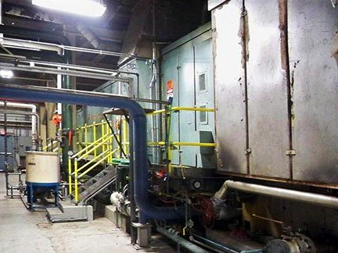

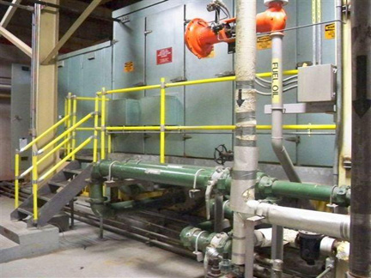

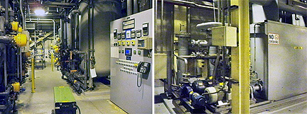

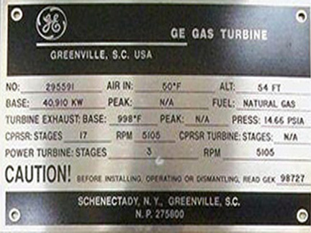
Gas Turbine
Manufacturer: General Electric
Model Number: PG6541B
Type: Continuous
Packaged By: GE
Rating (Base/Peak): 40,910 Kw
Inlet Temperature: 48 Deg F
Speed: 5,100 Rpm
Fuel: Natural Gas/Liquid
Inlet Air: Inlet Air Cooled
Nox Reduction: Water Injected
Gear Reducer
Manufacturer: Westech
Rating: 68000 Hp
Speed: 5100/3600 Rpm
Generator
Manufacturer: General Electric
Type: Tewac
Rating: 47,700 Kva
Voltage: 13800 V, 3phase, 60 Hz
Speed: 3600 Rpm
Pf: 0.9
Armature Amps: 1845 Amps
Insulation Class: F/F (Stator/Rotor)
Control: Mark IV Speedtronic
Black Start: Diesel Engine
Fuel: Natural Gas/Diesel
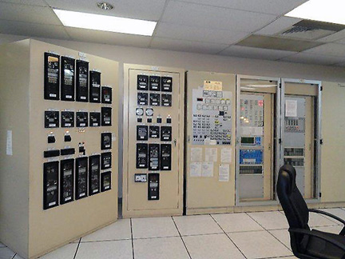

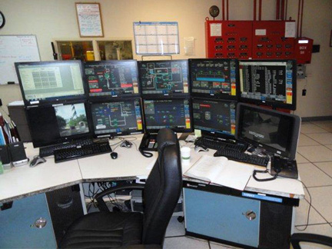
Nox Control: Water Injected
HRSG
Manufacturer: Nooter/Eriksen
Rating: 172,600 Lbs/Hr
Hp Steam: 1300 Psig/950 Deg F
IP Steam: 190 Psig/450 Deg F
Emission Control: Ammonia Injection

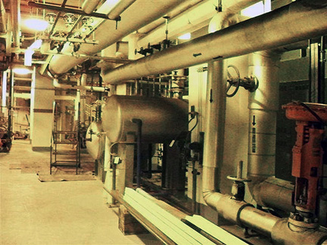
Year Built: 1990
Year Shutdown: Still Connected
Total Life Time Hours 84,936 Hours
Total Life Time Starts: 1,182
Hours Since Last Major Overhaul 1999: 27104 Hours
Starts Since Last Major Overhaul 1999: 714
Hours Since Last Hot Gas Path Inspection: 3,226

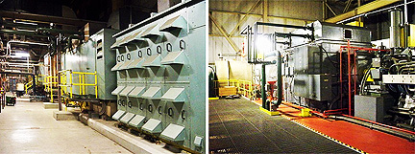

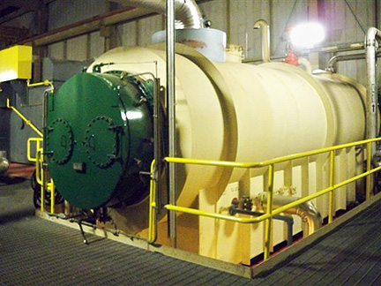

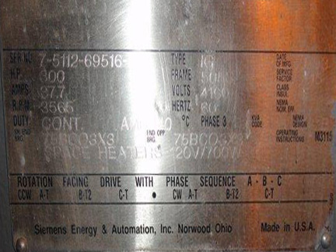

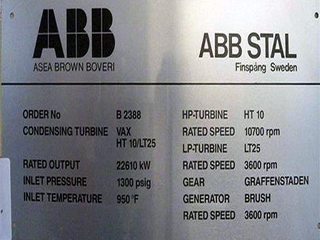

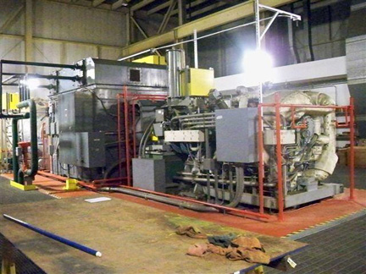

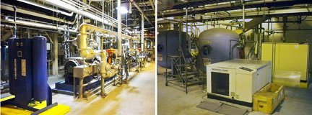

Steam Turbine Generator
Manufacturer ABB Vax Axial Exhaust
Rating: 22610 Kw
Pressure Temperature Flow 1300 Psig
Inlet Steam: 950 Deg F 172,600 Lbs/Hr
Exhaust Steam: 0.74 Psia
Process Steam: 22,515 Lbs/Hr @ 180 Psig
Generator
Manufacturer: ABB
Rating: 27,300 Kva
Voltage: 13800 V, 3 Phase, 60 Hz
Pf: 0.9
Speed: 1800 Rpm
Armature Amps: 1144 Amps
Exciter: Brushless, PMG
Type: Tewac
Natural Gas Pressure Inlet To Gas Compressor: 90 Psig
Scope Of Supply Complete Plant With Fuel System, Water System Etc
Cooling Tower, Liquid Fuel Tank And Pumping System From Tanker, Ammonia
Injection System, Gas Compressor, Plant Air Etc.

