 | CFAS Enterprises Inc.  After Market Utility Power Equipment Brokerage  Mailto:Staff@CFASPower.com  Turbine URL: http://CFASPower.com/Inventory.html  Reciprocating URL: http://CFASPower.com/Recips.html
GTG_1654GR_2LM5000CC_60Hz.doc

2 x 1 On 1 LM5000 100 Mw Gas Turbine CC Gas 60Hz Power Plant

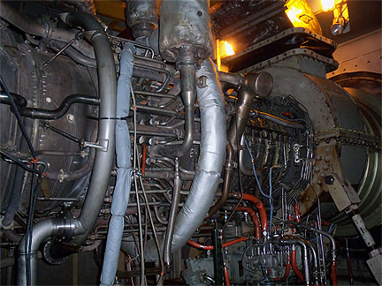

Asking Price: US 4.35 MM
YOM: 1991

Gas Turbine Generator #1

Package: Stewart & Stevenson
Turbine Manufacturer / OEM: GE Aircraft Engines
Serial number: 474-161
Model: LM5000-GD-NGA
Rating: 42024Kw
Time Since Overhaul: 8716 hrs
Meter hours: 25,738
Hot Section Hours: 8716
Total GT Hours: 53,786
Fuel: Natural Gas
Heat Rate: 10,506 BTU/KWH
Plant: 9075 BTU
Steam Adjusted: 7815 BTU

Power Turbine
GEC Gas Turbines Limited of England
Model: T-5000-1
3 Stage free spinning design

Generator: BRUSH
Model: 61404A-1G
Frame Size: 8DAX 75 - 290E
Output MVA: 34.8
Power factor: 1.0
Voltage: 13800
Frequency: 60
Speed: 3600
Specification: ANSI C 50-14

Download Unit No. 1 Operating Record

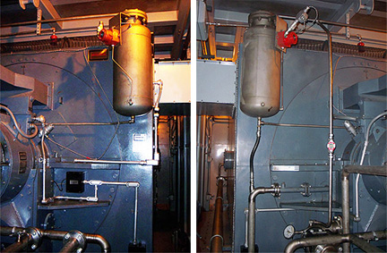

Gas Turbine Generator #2

Package: Stewart & Stevenson
Turbine Manufacturer / OEM: GE Aircraft Engines
Serial number: 474-160
Model: LM5000-GD-NGA
Rating: 42024Kw
Time Since Overhaul: 12,270 hrs
Meter hours: 2,087
Hot Section Hours: 1319
Total GT Hours: 53,976
Fuel: Natural Gas
Heat Rate: 10,506 BTU/KWH
Plant: 9075 BTU
Steam Adjusted: 7815 BTU

Power Turbine
GEC Gas Turbines Limited of England
Model: T-5000-1
3 Stage free spinning design

Generator: BRUSH
Model: 61404A-2G
Frame Size: 8DAX 75 - 290E
Output MVA: 34.8
Power factor: 1.0
Voltage: 13800
Frequency: 60
Speed: 3600
Specification: ANSI C 50-14

Download Unit No. 1 Operating Record

LM5000 Gas Turbine Spare Parts

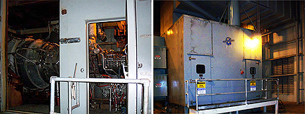

Elliot Steam Turbine Generator

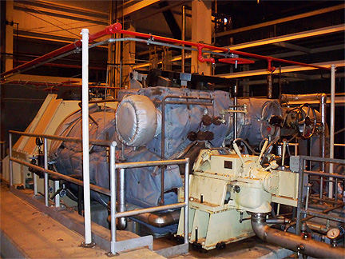

Model: 2SQNV13
Serial No. Shop Order No,: C004015

TURBINE SPEED:
Rated: 3600 rpm
Idle Speed: 1200 rpm
Minimum Governor Speed: 3420 rpm
Maximum Governor Speed: 3780 rpm
Overspeed Trip (Electrical): 3888 rpm
Overspeed Trip (Mechanical): 3960 rpm
1st Calculated Critical: 2100 rpm
2nd Calculated Critical: 5700 rpm
Generator Speed: 3600 rpm
Maximum Extraction Flow: 150,000 lb/hr

RATED POWER: 16,430kW

GOVERNOR:
Type: WOODWARD 505E
Speed Range 3420 to 3780rpm
3 to 15psi
4 to 20ma

RATED
Inlet Pressure: 650psig
Inlet Temperature: 675°F
Extraction Pressure: 175psig
Extraction Temperature: 473°F
Exhaust Pressure: 2.25"HgA

CONSTRUCTION:
Inlet Pressure: 650psig
Inlet Temperature: 680°F
Extraction Pressure: 280psig
Extraction Temperature: 533°F
Exhaust Pressure: 15psig

SHAFT ROTATION: Clockwise Viewed from Governor End

Elliot ST-G Operating Record

2ed Elliot ST-G available Along With Spares to OH

