 | CFAS Enterprises Inc.  After Market Utility Power Equipment Brokerage  Mailto:Staff@CFASPower.com  Turbine URL: http://CFASPower.com/  Reciprocating URL: http://CFASPower.com/Recips.html
GTG_1651RC_AEG5341DF_50Hz.doc

2 x Used MAN AEG PG5341G 25.6Mw 50Hz 10.5KV Dual Fuel Generators

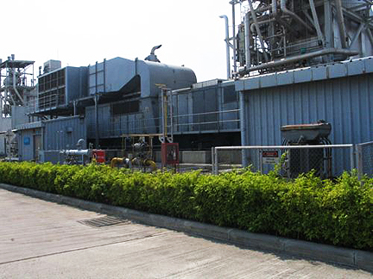

Price Is US $2.1MM Each

Gas Turbine
Manufacturer: AEG Kanis
Model: PG5341P
Number Of Units: 2
Rating (Base Load): 25600 Kw Each (Iso)
Rating (Site Rating): 19,500 Kw Oil
(37.8 Deg C) 20,000 Kw Natural Gas
Inlet Air Temperature: 37.8 Deg C.
Inlet Air : 1.0133 Bar
Fuel : Liquid/Natural Gas
Heat Rate (Lhv): 12,230 Btu/Kwh (New Condition)
Air Inlet System: Air Filter
Exhaust System : Side Exhaust (Not Included)
Starting : Diesel Engine Model 12v71v, 500 Hp
Turbine Exhaust Flow : 267 Lbs/Sec
Turbine Exhaust Temp: 518 Deg C
Nox Control: Water Injected
Shaft Speed: 5105/3000 Rpm
Rating: 30,000 Kw

Generator
Rating: 32,000 Kva
Kw: 26,600 Kw
Power Factor: 0.80
Frequency: 50 Hertz
Phase: 3
Voltage: 10,500
No. Of Poles: 2
Speed: 3000 Rpm
Connection: Wye
Type: Air Cooled
Enclosure: Outdoor Weatherproof
Turbine Control: Plc , Allen Bradley Logix 5000

History:
Year Built : 1981
Last Run: 2009

Unit-1 Unit-2
Total Hours Since New 199,872 199,197

Scope Of Supply
- Gas Turbine
- Liquid Fuel Pump Skid
- Starting Diesel Engine
- Reducing Gear
- Generator
- Control Panel
- Generator Air Circuit Breaker And Control Panel

