 | CFAS Enterprises Inc.  After Market Utility Power Equipment Brokerage  Mailto:Staff@CFASPower.com  Turbine URL: http://CFASPower.com/Inventory.html  Reciprocating URL: http://CFASPower.com/Recips.html
GTG_1649SS_Alison501.doc

1 x 1999 Allison5 01-KH5 6350KW 60HZ Gas Turbine CoGen Power Plant

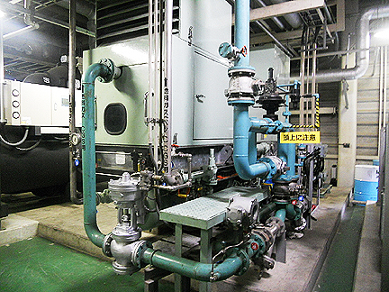

Asking Price: US $550,000 - as is where is

Gas Turbine

Maker: Allison
Output: 6350KW
Year: 1999.9
Revolution: 14,586rpm

Generator

Output: 7056KW
Year: 1999.9
Frequency: 60HZ
Revolution: 1800rpm
Voltage: 6600V
Phase: 3

