 | CFAS Enterprises Inc.  After Market Utility Power Equipment Brokerage  Mailto:Staff@CFASPower.com  Turbine URL: http://CFASPower.com/Inventory.html  Reciprocating URL: http://CFASPower.com/Recips.html
GTG_1647DM_AlphaLavalHFO.doc

Reconditioned Alpha Laval HFO Fuel Treatment Plants

Terms of Payment: TT in advanced
Terms of Delivery: As applicable

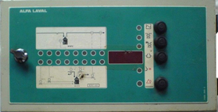

Alfa Laval EPC 41 AUTOMATIC Control Panel US $750

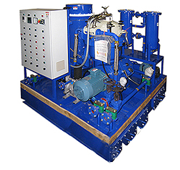

Recondition: Alfa Laval MAPX207 Along with Tolls Kit & Manual
Capacity: 5000 LTR/HRS US$7500

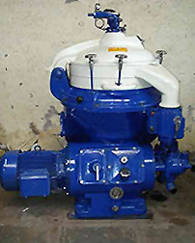

1- Recondition: Alfa Laval MAPX309 Along with Tolls Kit & Manual
Capacity: 9000 LTR/HRS US $8500

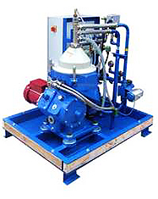
1- Recondition: Alfa Laval MAPX204 including Tool Kit & Manual
Capacity: 1500 LTR/HRS US $6500

