 | CFAS Enterprises Inc.  After Market Utility Power Equipment Brokerage  Mailto:Staff@CFASPower.com  - Turbine URL: http://CFASPower.com/Index.html  Reciprocating URL: http://CFASPower.com/Recips.html
GTG_1633GR_LM6000PAEngs.doc

1 x Used LM6000PA Core Engine For Sale

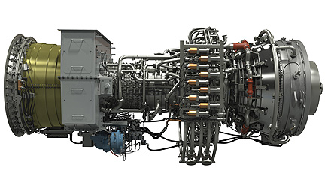

10,000 remaining hours before the overhaul

OPERATIONAL HISTORY
Year | 1996 | 1997 | 1998 | 1999 | 2000 | 2001 | 2002
Operational hours |  | Initial GT | Initial GT | Initial GT  Lease GT | 3974(LeaseGT)  3856 (25695h) | 4439 | 6884
Accumulative |  |  |  | 21791 | 29551 | 33990 | 40874
Year | 2003 | 2004 | 2005 | 2006 | 2007 | 2008
Operational hours | 7757 | 6906  1113(Lease GT) | 6156 | 76 | 105 | 23
Accumulative | 48631 | 56650 | 62806 | 62882 | 62987 | 63010
Total OP hours current GT = 36200

Fire Starts current turbine = 240

Overhauled when and by = Not overhauled yet. Hot section on December 2003 by General Electric

Date of last overhaul of the Gas Turbine and other equipment.
Not overhauled yet due to non having reached 50.000hours.
Hot section on December 2003 by General Electric

Asking Price EURO 2.2 MM

