 | CFAS Enterprises Inc.  After Market Utility Power Equipment Brokerage  Mailto:Staff@CFASPower.com  Turbine URL: http://CFASPower.com/Index.html  Reciprocating URL: http://CFASPower.com/Recips.html
GTG_1626TDG_PWFT8CHP_50Hz.doc

Pratt & Whitney FT8 DLN Powerpac 25.5Mw 50hz 11KV CHP Power Plant

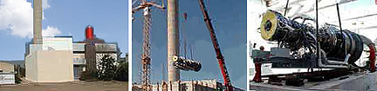

Asking Price: US $5.9 MM
Includes dismantling and repackaging for shipping for new owner. This plant is still operating and will be shut down on April 10, 2012.

The FT8-30 PowerPac drives a generator equipped with a downstream waste heat recovery boiler.

Download Pdf

Technical data

Gas turbine
Type: FT8-30 (PowerPac)
Rating: : 25,570 Kw
Speed: 3600 RPM
Compressor stages: 8/7
Turbine stages: 2/1
Electrical efficiency: 38.1%
Generator efficiency: 98%
Heat Rate: 9.440 kJ/KWh
8.60Btu/kWh
NOx emissions: 15% O2, dry 50.0 mg/Nm3
CO emissions 100.0 mg/Nm3
Efficiency: 37.05
Heat Production: 30,000Kw
NOx emissions: 15% O2, dry [mg/Nm3] 50.0
CO emissions: 100.0 mg/Nm3
Exhaust Gas Data
Exhaust Gas Temperature: 456°C
Exhaust Gas mass flow: 85.1 kg/s
188lb/s

Above specifications valid under the following conditions:
15°C (58°F) se level, no inlet/outlet loses. RH = 60%. Natural gas, η gen = 98%. *3600 rpm available on request.

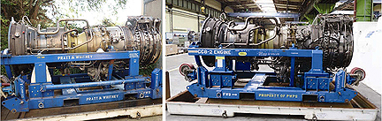

Weight approx.. DIN): 3,000(3,950) kg

Power Turbine
Speed: 3.000* rpm
Stages: 4
Weight Approx.: 6.000

History
Year Installed: 2000
Total Hours: 39643
Hours Since OH: 7007
Total Starts: 288

Alternator
Manufacturer: JEUMONT
Type : JISALT 235
Serial : 5I0470 T1
Power : 35038 kVA
Speed : 3000 tr/min
Voltage : 11000 V

Control System: Woodward Netcom

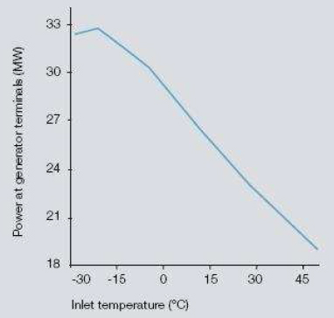

Sea Level, rel. humidity = 60%

