 | CFAS Enterprises Inc.  After Market Utility Power Equipment Brokerage  Mailto:Staff@CFASPower.com  Turbine URL: http://CFASPower.com  Reciprocating URL: http://CFASPower.com/Recips.html
GTG_1623VS_KawM1A03_60hz.doc

2 x Low Hours 1350 KW Kawasaki M1A-03 60Hz Diesel Fueled Generator

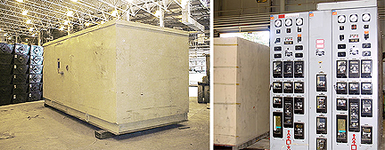

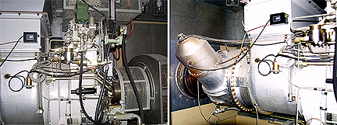

Asking Price: US $325,000.00 EACH

Manufacturer: Kawasaki
Fuel Type: Diesel
Model: M1A-03
Quantity: 2
Year: 1985
Serial Number: 526 Prefix
KW: 1350
Hz: 60
Voltage: 4160
RPM: 1800
Hours: 550 Since New

Stamford 734D two bearing generator rated at 1500kwMounted in soundproof container with all switchgear and controls.

Approx. net weight: 32,000 lbs. per generator set
Dimensions: 18 ft. long x 8 ft. wide x 8 ft. high

