 | CFAS Enterprises Inc.  After Market Utility Power Equipment Brokerage  Mailto:Staff@CFASPower.com  Turbine URL: http://CFASPower.com/Inventory.html  Reciprocating URL: http://CFASPower.com/Recips.html
GTG_1616PPS_RGEFm5N.doc

4 Low Hours GE Fm5N 25Mw Each (96 MW) Gas Fired Black Start / Peak Load Power Station

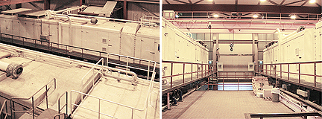

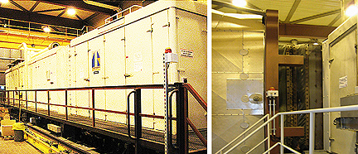

Asking Price: 2 .65 million Euro (as is where is)
Located in Europe

• Gasturbine
• Generator
• Diesel Engine
• Main Gearbox
• Auxiliary Gearbox
• Speedtronic Mark II control system
• Exhaust plenum
• Air inlet filter house

The four Units are currently installed parallel to each other at an elevation of approximately 3.5 meters above ground level of the power plant. A schematic overview of the whole plant is provided below giving an impression of how the Units are placed within the whole building.

UNIT1 UNIT 2

GASTURBINE

Manufacturer General Electric General Electric
Type MS5001 / N MS5001 /N
Model NANCY NANCY
Name plate rating 24 MW 24 MW
Compressor stages 17 stages (incl. IGV's) 17 stages (incl. IGV's)
Turbine stages 2 stages 2 stages
Exhaust gases Direct to chimney Direct to chimney
Compressor rate 1 :9 1 :9
Speed 5121 rpm. 5121 rpm.
Control system Speedtronic (Mark II) updated to DCS Speedtronic (Mark II) updated to DCS
Fuel Natural Gas Natural Gas

GENERATOR

Manufacturer SMIT Slikkeveer (Brush HMA) SMIT Slikkeveer (Brush HMA)
Type DTG 175/200/80 DTG 175/200/80
Serial number NO: 1 -1885-1B3 NO: 1 -1885-1B4
Name plate rating 30.000 kVA 30.000 kVA
Rate capacity 10,5kV/1652A 10,5kV/1652A
Frequency 50 HZ 50 HZ
Speed 3000 rpm. 3000 rpm

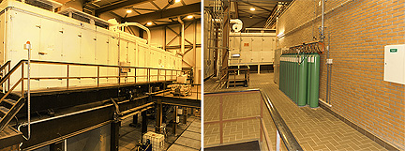

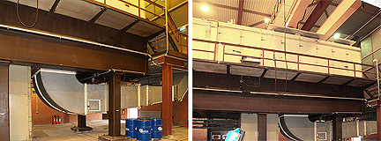

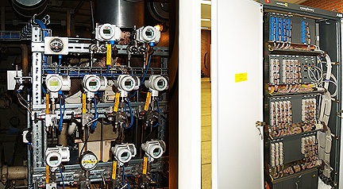

DIESEL ENGINE

Manufacturer Detroit Diesel Allison DIV. G.M.C. Detroit Diesel Allison DIV. G.M.C.
Model 71237000 71237000
Power 500 PK 500 PK
Speed 2300 rpm 2300 rpm
Fuel Gasoline Gasoline

MAIN GEARBOX

Manufacturer Alcatel - Graffenstaden Alcatel - Graffenstaden
Type R - VF - 63 R - VF - 63
Speed reduction 5120/3000 rpm 5120/3000 rpm
P max/ nominal 30000 / 27000 kW 30000 / 27000 kW

AUXILIARY GEARBOX

Manufacturer Alcatel - Graffenstaden Alcatel - Graffenstaden
Type A500 BG 2 BM A500 BG 2 BM
Speed reduction 5120 / 3582,6 /1684,2 /1445 RPM. 5120 / 3582,6 /1684,2 /1445 RPM.
Connected with Main lubrication oil pump, cooling water pump, fuel oil pump. Main lubrication oil pump, cooling water pump, fuel oil pump.

OPERATING DATA

In operation Since 1974 Since 1975
Total Hours (End of 2010) 6119 5807
Hours SLMOH (End of 2010) 2506 2557
Total Starts (adjusted for trips with factor 8/trip) (End of 2010)
2616 2539
Starts since last Major Overhaul (adjusted for trips with factor 8/trip) (End of 2010) 363 454
Last Major Overhaul in: 2002 2002
Last inspection Boroscope inspec in 2010 2009 Comb.insp. 2010 Boroscope insp.

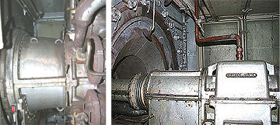

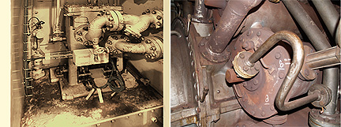

UNIT3 UNIT 4

GAS TURBINE

Manufacturer General Electric General Electric
Type MS5001 / N MS5001 / N
Model NANCY NANCY
Name plate rating 24 MW 24 MW
Compressor stages 17 stages (incl. IGV's) 17 stages (incl. IGV's)
Turbine stages 2 stages 2 stages
Exhaust gases Direct to chimney Direct to chimney
Compressor rate 1 :9 1 :9
Speed 5121 rpm. 5121 rpm.
Control system Speedtronic (Mark II) updated DCS Speedtronic (Mark II) updated to DCS
Fuel Natural Gas Natural Gas

GENERATOR

Manufacturer SMIT Slikkeveer (Brush HMA) SMIT Slikkeveer (Brush HMA)
Type DTG 175/200/80 DTG 175/200/80
Serial number NO: 1 -1885-1B1 NO: 1 -1885-1B2
Name plate rating 30.000 kVA 30.000 kVA
Rate capacity 10,5kV/1652A 10,5kV/1652A
Frequency 50 HZ 50 HZ
Speed 3000 rpm. 3000 rpm.

DIESEL ENGINE

Manufacturer Detroit Diesel Allison DIV. G.M.C. Detroit Diesel Allison DIV. G.M.C.
Model 71237000 71237000
Power 500 PK 500 PK
Speed 2300 rpm 2300 rpm
Fuel Gasoline Gasoline

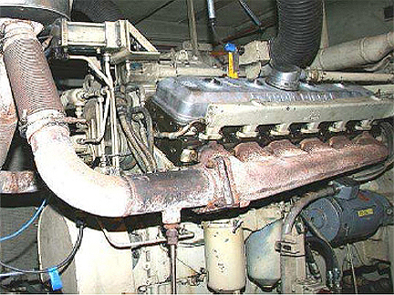

MAIN GEARBOX

Manufacturer Alcatel - Graffenstaden Alcatel - Graffenstaden
Type R - VF - 63 R-VF-63
Speed reduction 5120/3000 rpm 5120/3000 rpm
P max/ nominal 30000 / 27000 kW 30000 / 27000 kW

AUXILIARY GEARBOX

Manufacturer Alcatel - Graffenstaden Alcatel - Graffenstaden
Type A500 BG 2 BM A500 BG 2 BM
Speed reduction 5120 / 3582,6 /1684,2 /1445 RPM. 5120 / 3582,6 /1684,2 /1445

Connected with Main lubrication oil pump, cooling water pump, fuel oil pump. Main lubrication oil pump, cooling water pump, fuel oil pump.

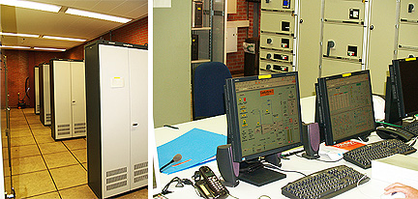

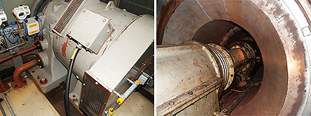

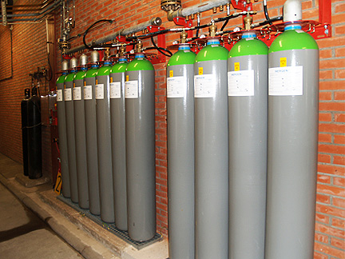

Operating Data

In operation Since 1976 Since 1977

Total Hrs (12/2010): 6570 5693

Hrs SLMOH (End of 2010)
1774 2812

Total Starts (Endof2010)
2698 3181

Starts since last Major Overhaul (adjusted for trips with factor 8/trip)(End of 2010)
337 570

Last Overhaul in: 2004 1999

Last inspection Boroscope inspection in 2010 2006 Comb.insp., 2010

1. Emergency Power Unit

DIESEL ENGINE

Manufacturer CAT
Type D343

GENERATOR

Manufacturer AVK
Type DiB80E/4D

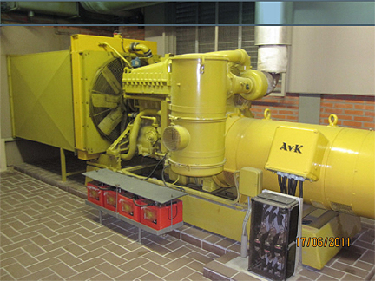

2. Transformer

Transformer
In operation 1974
Voltage range 10 kV / 150 kV
Power 125 MVA

3. Cooling Unit

Picture of Cooling Unit

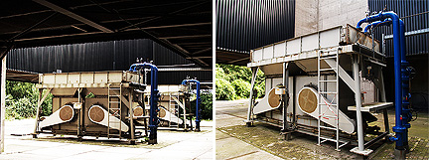

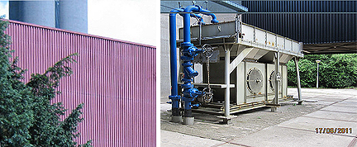

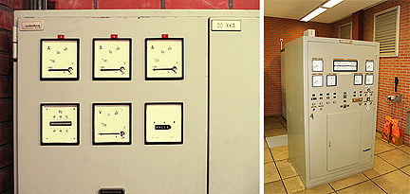

General technical remarks

• It cannot be guaranteed the equipment is fully asbestos-free; However, during regular maintenance exercises asbestos was removed instantly when identified. So, at places in the turbines that are commonly reviewed for maintenance purposes, no asbestos will be found.

• The machines were mainly deployed for 'black-starts' which explains the relatively high ratio of number of starts over number of operating hours

• The Units can be controlled individually. Only limited investment required to do so (Control system need be connected to a regular PC with monitor and some software). Details can be provided once a deal is secured.

Terms and conditions

• Seller keeps the right to withdraw this offering from the market.

• Buyer candidates that exhibit serious interest in the equipment can be offered to show the machines in operation and inspect maintenance reports.

•Dismantling, shipping and re-installation are not part of this offer. However, PPS can assist in finding local parties for these services. We are able to work with Buyer on an estimate of the dismantling, storage and/or transportation costs to the Port of Rotterdam.

• Verification of the availability of funds is required.

• Buyer will be required to render a 10 % Earnest Deposit to secure the Option to Purchase which is non-refundable after inspection and acceptance. Balance of 90% of purchase price is due at closing. Financial closing shall take place 30 days before Removal Date. Removal Date is the date at which the equipment is actually removed from the site and shall be specified and agreed between Buyer and Seller.

• PSS makes no warranty or representation regarding the accuracy or correctness of the information contained herein. The responsibility for assessing the accuracy or correctness of that information resides with the buyer. Seller is willing to provide an estimate of the dismantling and transportation costs to the Port of Rotterdam. This information can be provided to potential buyers per July 1st 2011 by contacting Seller .

• Unit: Unit is defined as described in section 'Specification of Offering'

• On offer: 4 Units; that may be sold separate^.

• Availability: Ql-2012 (estimated time frame; negotiable)

• Inspection while in operation: Between July and November 2011

• Freight: Buyer is to arrange pickup and transportation from Site location

• Warranty: As is/Where is

• Dismantling, crating & transport: - Method of dismantling, crating and transportation to be determined and executed by Buyer.

- The costs of such activities will be incurred by Buyer

- Activities are to be coordinated with Buyer and executed in accordance with applicable internal safety and environmental guidelines

• Removal Date: The date of removal of the equipment from the plant is to be agreed among

• Buyer and Seller after August 2011.

the Dismantling and transportation of the premises have to be performed according the requirements / instruction of the current operator.

• The terms of payments, down payments, LOI's will have to be discussed.

• Subject to availability

• We would like to receive an offer for the four units, or for individual units

• Inspection while in operation before November 2011

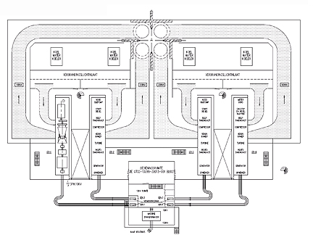

GENERAL

This document together with any additional documentation signed by Seller and Buyer represents the Agreement between the parties.

These terms may not be modified except in writing signed by an authorized representative of Seller. Any terms and conditions submitted in Buyer's inquiry or purchase order shall be null and void unless specifically agreed to in writing signed by an authorized representative of Seller. Catalogs, circulars and similar pamphlets of Seller are provided for general information purposes only and are not a part of the Agreement. Except as expressly contained herein no representation or warranty is made as to performance, size, durability, or other specifications of Sellers products and any information contained in catalogs, circulars and similar promotional or advertising material is for general informational purposes only.

TAXES/DUTIES

Any sales, use or other similar type taxes or import or export duties imposed on this transaction are not included in the price. Such taxes and/or duties shall be billed separately to Buyer. Seller will accept a valid exemption certificate from Buyer if applicable; however, if such exemption certificate is not recognized by the governmental taxing authority involved and Seller is required to pay the tax covered by such exemption certificate, Buyer shall promptly reimburse Seller for the taxes paid.

EXCUSABLE DELAYS

Seller shall not be responsible for nonperformance or delays in performance occasioned by any causes beyond Seller's reasonable control, including, but not limited to labor difficulties, delays of vendors or carriers, Seller's prompt receipt of Buyer's equipment, Seller's compliance with Buyer's change orders, fires, acts of God, war, non-governmental actions and material shortages. Any delays occasioned by such circumstances shall affect a corresponding extension of Seller's performance dates.

If interested in the plant as a whole, please contact the person mentioned under 'Contact details'.

WARRANTY

The Units are sold As is/Where is, without warranty, unless specifically agreed to elsewhere and the effects of corrosion, erosion and normal wear and tear are specifically excluded and Seller will be held harmless. Seller will not be liable to Buyer for any loss or injury to persons or property (including the machinery which is the object of the work) caused in whole or in part by (1) the acts of Buyer or its agents, (2) failure to observe Seller's instructions, or (3) failure or malfunctioning of anything not furnished by Seller.

The preceding paragraphs set forth the exclusive remedies for warranty claims, and upon the expiration of the warranty period, all such liability shall terminate.

HSSE

During the performance of dismantling of the equipment on Seller's premises, the work shall be executed in accordance with Current Operator safety instructions and procedures. Failing to act in accordance with these Safety procedures and instructions will lead to (temporary) stopping of the dismantling activities.

