 | CFAS Enterprises Inc.  After Market Utility Power Equipment Brokerage  Mailto:Staff@CFASPower.com  Turbine URL: http://CFASPower.com/  Reciprocating URL: http://CFASPower.com/Recips.html
GTG_1610DSS_KawM1A13A_50Hz.doc

1 Used KAWASAKI M1A-13A GT 1500Kw 50Hz 63Kv Gas Turbine CHP Plant

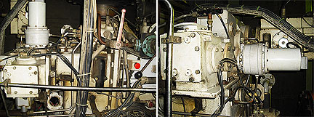

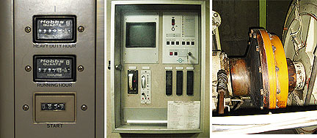

Asking Price M1A-13A Gas Turbine Generator Alone: US $350,000 As is/Where Is
Asking price including HRSG: US $600,000 As is/Where Is

***Gas Turbine was shut down 2008-09 due insufficient Natural Gas but the Boiler is still in use through duct firing.

Make and Model of Genset: Kawasaki M1A-13A
Name of original packager Deutz MWM KHD Germany
Year of manufacture 1994
S/N of Package G 806730
Original installation date 1994
Total hours 23862
Total number of starts 177

Scope of Supply

1- Gas Turbine M1A-13A Kawasaki Up To Turbine Exhaust Chimney
2- Alternator 1500kwh, 1875kva, Type LSA52 V L-9-4P
3- L M F Gas Compressor, 600nm3/H
4- Eco Gas Compressor 700nm3/H
5- Turbine Starter
6- Electrical Panels For Turbine & Gas Compressors
7- PLC Siemens
8- Emergency Battery System
9- Co2 System
10-Gas Reservoirs (Bottles)
11-Switch Gear & Transformer
12-Inlet Filtration System & Cooling Coil

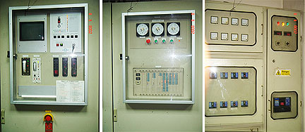

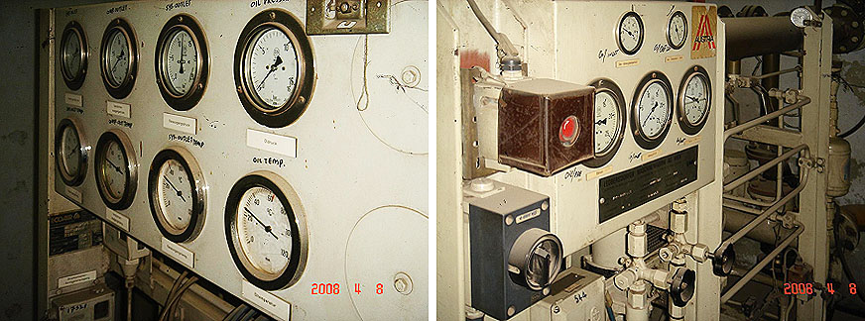

ISO Site

Parameters Conditions Conditions

Installation:
Elevation, meters above sea level 0 200Mtrs
Ambient Temperature, ºF (hot summer day) 59 118
Design Inlet Filter Loss, in. H₂0 50 mm H2O
Design Exhaust System Loss, in.H₂0 50mm H2O
Design Exhaust Stack Exit Temperature, ºF 418 (1)
Fuel Heat Content (LHV), BTU/SCF 950
Fuel Pressure Required, psig 175

Gas Turbine Generator Set:
Turbine Shaft Power, MWe 1471
RPM 22,000
Make of generator Leroy Somer France
Generator speed (RPM) 1500
Generator model LSA52 VL-9-4P
Generator Power, MWe 1500kW or 1875kVA
Output Frequency 50Hz
Output voltage from package 6300V/3Phase
Transformer voltage 6300/400

Electrical Thermal Efficiency 24%
Exhaust Gas Flow, lbs./hr 1235 m³/min (515ºC)
Exhaust Gas Temperature, ºF 1022 ºF
Fuel Consumption, SCFM 0.46 Nm3 (At site)
Gear Box Manufacturer HITACHI JAPAN
Gear Box model 2004
Gas Compressor Make/Model ECO AIR COMP GERMANY/1994
& LMF GERMANY /1989
Gas Compressor output (psi and CFM) ECOAIR 711Nm3/Hr (4Bar~13Bar) LMF 600Nm3/Hr (4~16Bar)

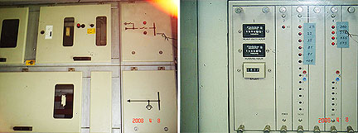

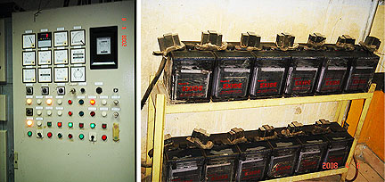

Make of inlet filter system England
IS the inlet filter self cleaning (yes or no) Yes
Mike of oil cooler if any Germany
Control Siemens PLC System Semitic S 5
Make of fire control system Germany
Lube tank capacity in skid 200
Skid dimensions L: 5300*W: 2000*H: 750mm
Skid Weight 15000Kg
Compressor skid dimensions ECOAIR (2200*1300*150mm)
LMF (2250*1050*300mm)
Gas conditioning skid if any – provide description

Kawasaki (M1A-13A) Gas Turbine
1 Industrial Gas Turbine Engine Characteristics
Power Section & Gear Box Renewed On 5th Nov 2004

Base Load Power (Bhp) Kw 1,972(1,471)
(Peaking Model)

Turbine Speed 22,000 Rpm
Out Put Shaft Speed 1500 Rpm
Nominal 100% Rpm

Out Put Shaft Rotation (Facing Shaft) Clockwise
Engine (Reduction Gear Box Included) 6,6000 (3000)
Power Section Only 2,200(1,000)
Dimensions, Inch (Mm) Inch (Mm)
Length 83(2,100)
Width 55(1,400
Height 63(1,600)

Alternator
Type LSA52 Vl-9-4P
S/N 161768-1
Power 1500 Kwh/1875 Kva
Frequency 50
Phase 3
Amb Temp 40
DE BRG 6232MC3
NDE BRG 1028mc3
Grease Shell Alvania G3
Qty 70grm
After 2800hrs

2 GAS TURBINE, LMF GAS COMPRESSOR AND GENERATOR SET
    - Maintenance Record
- Present Gas Turbine Running Hrs.
  - Gas Turbine Start No: 177
  - Heavy Duty Hrs. 67
  - HSI (Hot Section Inspection) Date- 17-12-2006
  - His Running Hours Hrs. 16723
  - BSI Date Date 12-05-2007
  - BSI G T Running Hrs. Hrs. 18477

- (Ii) Generator Maintenance Date 12-05-2007
  - De And NDE Bearings Replaced With New One

- LMF Gas Compressor Maintenance
  - Compressor Running Hrs. Hrs. 16523
  - Cylinder Sleeves Replaced 4
  - Pistons Ring Sets Replaced
  - Connecting Rod Replaced 4

- 3 Eco Gas Compressor With Manual
  - Type Screw MS 50e-5/13-6
  - Nr 901187868
  - Baujahr Screw
    - Volumenstrom 11.85nm3/Min
  - Verdichtungsenddruck 13 Bar
  - Drehzhl 8265 1/Min
  - Motorleistung 37kw

- 4 LMF Gas Compressor Manual

  - Compressor Type VP2/1413 L 1.5
  - Number Of Cylinders 4
  - Compressor Design Fan Shaped
  - Medium Natural Gas
  - Capacity (Ref. To 0C 1,013 Bara 600 Nm3/H
  - Inlet Pressure 412 Bar
  - Intel Temperature 15c
  - Discharge Pressure 13.5 Bar

LMF Compressor Dimension And Weight (Approx.)

Compressor Control Station

  - Length 2250mm 1530mm
  - Width 1330mm 330mm
  - Height 1790mm 1280mm
  - Weight Approx. 2300kg

- 5 Looker Filtration (Intake Filter) With Manual

  - Application Gas Turbine Air Intake
  - Design Airflow 420m3/Min
  - Initial P.D 22mmwg
  - Efficiency (Gravimetric Efficiency)
  - Life (Element change Working Hrs.)

- 6 Filter Elements

  - Filter Element Type HE 100702
  - Total Quantity 28 Off
  - Media Area 18 Sq./Element
  - Nominal Size 324mm O/Diax212mm/Diax700mm Long
  - Approx. Weight 7.2 Kg
  - Gasket Neoprene

- 7 Turbine Starter With Manual

  - 380V VDE MAX 1800
  - 90KW 1480 PN 315 BAR
  - 50HD COS P MAX 400BAR
  - IP54 1660
  - NR 2912 MAX 1800
  - VG MAX 130CM3 PN 315 BAR
    - 12 75MM2/S P MAX 400BAR

- 8 Electrical Control

Siemens PLC System Type Simetic S-5

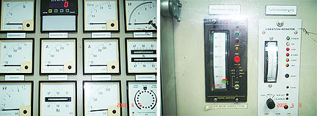

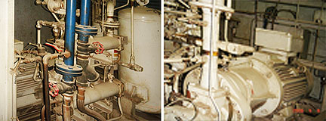

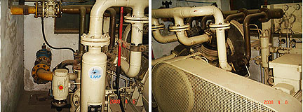

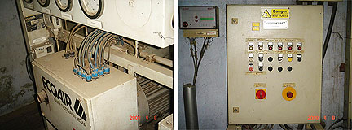

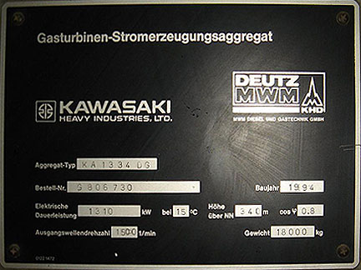

Heat Recovery Steam Generator

HRSG Make & Model Johnston Heat Recovery (Nebraska USA)
Design Pressure, PSIG 200 Psi
Operating Steam Pressure, PSIG 150 Psi
Hydrostatic Test Pressure, PSIG 300 Psi
@ Design Temperature, ºF 400 Fº
Heat Recovered, MBTU/hr. (approx.) 2667KWS
Steam Temperature, ºF (approx.) 350 Fº
Steam output (tons/hr.) 4.6 Ton

Age of Boiler 26/01/2002
Boiler configuration DUCT FIRED

Description of Boiler
Boiler Heating Surface: 9121 SQFT
Economizer Heating Surface: 3000SQFT
Steam from Exhaust: 4.6 Ton
Steam from Duct Burning: 10.4 Ton
Additional Steam Storage Drum: 4’*6’

