 | CFAS Enterprises Inc.  After Market Utility Power Equipment Brokerage  Mailto:Staff@CFASPower.com  Turbine URL: http://CFASPower.com/Index.html  Reciprocating URL: http://CFASPower.com/Recips.html
GTG_1597DSS_TaurasT60_50Hz.doc

5 x NEW Solar T-60 (T60-7901) 5.67 MW 11KV 50Hz Dual Fuel Gas Turbine Packages

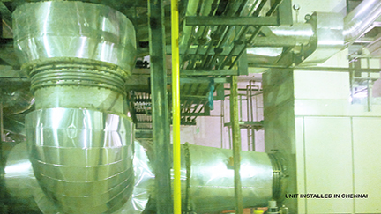

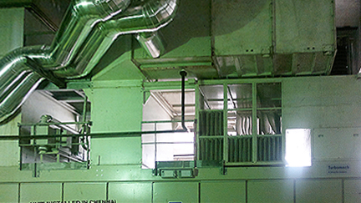

Asking price: US $2.49 MM Each

Electrical Power: 5.67 MW
Heat rate: 10'832 Btu/kW-hr
Fuel input; 17.1 MBtu/s
Efficiency: 31.5 %
Exhaust gas flow: 48.0 lb/s
Exhaust gas temperature: 950oF
Fuel: NG/LF/LPG/LBTU
Start System: AC
Generator Voltage: 6.3 or 11kV
Combustion System Available: S/WI/DLE

Technical Specs of Each GTG package
Gas Turbine Generator Module Taurus 60 (T60-7901)-1

1.1 Industrial Gas Turbine
Compressor assembly
Turbine and combustor assembly
Combustion system

1.2 Reduction Gear-1
Two stage, star compound epicyclic type

1.3 Coupling-1

1.4 AC Synchronous Generator 50 Hz, 11 kV
Brushless excitation system
Protection: IP21
Insulation class: H
Temperature rise class: F
Self-ventilated air cooled
Accessories and instrumentation

1.5 Starting System-1
Hydraulic start motor-1
Hydraulic oil filter-1
Hydraulic pump-1

1.6 Dual Fuel System-1

1.6.1 Natural Gas Fuel System-1
Gas filter-1
Fuel shutoff valves-2
Fuel control valve-1
Fuel manifold-1
Instrumentation
Internal piping-1
Gas flow meter-1

1.6.2 Liquid Fuel System
Duplex filter-1
High pressure speed controlled pump-1
Filter-1
Fuel shutoff valves-2
Fuel manifold-1
Air assist system-1
Drain tank-1
Instrumentation-1
Internal piping-1

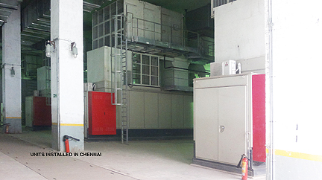

1.7 Water Injection System-1
Water inlet filter-1
Motor driven pump-1
Valves and control devices-1

1.8 Lubrication System-1
Lube-oil tank-1
Lube-oil heater-1
Main lube-oil pump-1
Pre/post lube-oil pump-1
Lube oil cooler-1
Duplex lube-oil filter-1
Electrostatic vapour extractor-1
Indicators and instrumentation
Internal piping

1.9 GT Compressor Washing System-off-line and on-line
Water tank-1
Water manifold-1
Instrumentation & Internal piping-1
On-line washing system-1

1.10 Base Frame-1

1.11 Vibration Dampers-6

2 Sound -85dB(A)at1m, green field conditions-1
Air Filtration System
Air filter housing
Alarms & Instrumentation

3.1 Combustion air filtration system

3.2 Ventilation air filter system
Electric Motor driven air blowers
Pneumatically driven air shutters

4 Control System

4.1 TUMATRONIC S4 Turbine Control System-1
Backup Failsafe PLC-1
PC "Real time"-1
PC HMI with touch screen TFT-1
Profibus acquisition modules-1

4.2 Generator Control, Synchro. & Auxiliary Syst.
Generator measurement unit-1
Generator voltage regulation-1
Generator protection-1
SPM Synchroniser-1
Vibration monitoring system-1
Gas leakage detection system-1
CosPhi Card-1

4.3 Control System Interface
Signal exchange-1
Standard connection with supervisory control sys installed in customer control room-1
Desktop remote PC-1
Client supervision control system interface data processing excluded-1

5 Electrical System

5.1 AC Supply System

5.2 DC Supply System-1
24 V/DC battery charger-1
24 V batteries-1 set
24 V distribution bus-1

5.3 Starting Cubicle

6 Fire Detection & Extinguishing. Equipment
Electronic control unit
Infra-red detectors-2
Release push-button-1
Horn & light signalisation-1
Spray nozzles-4
C02 bottles-4

