 | CFAS Enterprises Inc.  After Market Utility Power Equipment Brokerage  Mailto:Staff@CFASPower.com  Turbine URL: http://CFASPower.com/Index.html  Reciprocating URL: http://CFASPower.com/Recips.html
GTG_1591NC_ABB44KVA_Genend.doc

44 MVA ABB Make Synchronous Generator

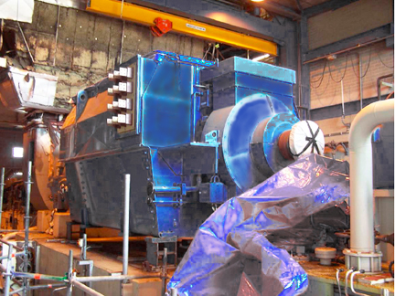

Asking Price: Euro 270,000

Manufacturer: ABB Drives AB
Model: GBA1250 LD
Type: Brushless Synchronous Protection: IP 54
Cooling Arrangement: ICW37A81
Apparent Power: 44000 kVA
Active Power: 35,200 kW
Power Factor: 0.8
Rated Speed: 1500 RPM
Voltage: 10500 V +/- 5%
Current: 2419 A
Phases: 3
Connection: Star
Frequency: 50 Hz

Exciter: Brushless
Voltage: 85 V
Current: 12 A
Coolant: Water
Stator Insulation Class: F
Rotor Insulation Class: F
Poles: 4
Direction of Rotation: Counter Clockwise

NOTE :
• The above Alternator is Currently In Storage.
• The Alternator has been very sparingly used & is In Excellent Condition.

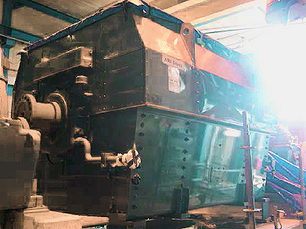

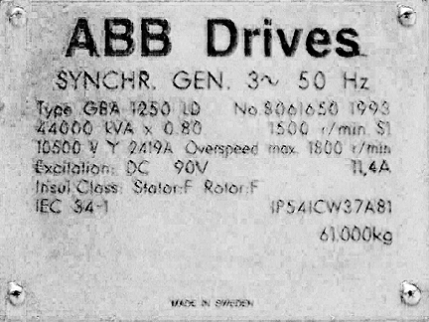

3

