 | CFAS Enterprises Inc.  After Market Utility Power Equipment Brokerage  Mailto:Staff@CFASPower.com  Turbine URL: http://CFASPower.com/Index.html  Reciprocating URL: http://CFASPower.com/Recips.html
GTG_1590NC_LeroySomer8750kVA_Genend.doc

1 x 8750 kVA, LEROY SOMER (2004)

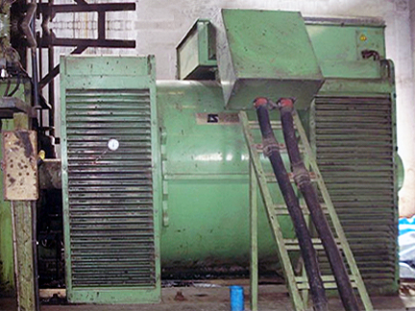

Asking Price: US $155,000

Technical Details :
Make: Leroy Somer, France
Model: LSA 60B 125/12P
Capacity: 8750KVA
Year of Make: 2004
Active Power: 7000 kW
Speed: 500 RPM
Voltage: 11000 V
Phase: 3
Cycles 50 Hz
P.F.: 0.80

CONDITION :
The Above Alternator is in Excellent Condition & can be presently inspected on foundation in India. The Alternator is presently coupled to Sulzer 16VZAV40/48 Engine.

