 | CFAS Enterprises Inc.  After Market Utility Power Equipment Brokerage  Mailto:Staff@CFASPower.com  Turbine URL: http://CFASPower.com/Inventory.html  Reciprocating URL: http://CFASPower.com/Recips.html
GTG_1562WTS_EGT_Althom_50Hz.doc

1 x 1997 EGT Alsthom 5Mw 50Hz CHP Power Generator Plant

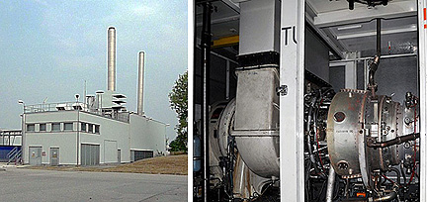

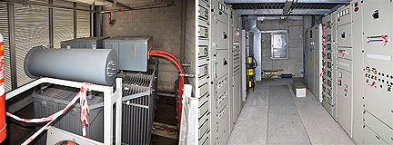

Manufacturer: SIEMENS
Model: EGT ALSTHOM
Seriel: DIN B 6271
Fuel: Natural Gas
Capacity: 5.000 KW
Phase: 3
Volts: 380 V
Frequency: 50 Hz
Speed: 1.500 RPM
YOM: 1997
Total hours: 79072
Totally Refurbished: 2005
Hours Since Last OH: 27.000 hours
Next Overhaul @: 35.000 hours

**The generator is NOT in cold standby. It has been shut down in 2010.

Steam Boiler
Capacity: 20 TON/ HOUR AT 20 BAR

