 | CFAS Enterprises Inc.  After Market Utility Power Equipment Brokerage  Mailto:Staff@CFASPower.com  Turbine URL: http://CFASPower.com/Inventory.html  Reciprocating URL: http://CFASPower.com/Recips.html
GTG_1561WP_LM5000_60Hz.doc

2 Rebuilt x GE LM5000 S&S 42Mw Gas Turbine 60Hz Packages

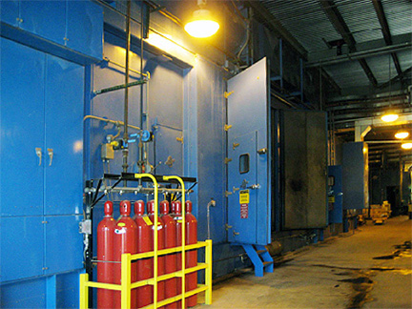

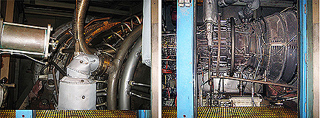

Asking Price: US $16.8 MM Both

Download Complete Packing List

SPECIFICS AND HISTORY

Unit 1
Manufacturer & Model: General Electric 7LM5000-GD-NDBG07
Serial Number: 474-179
Power Turbine: General Electric T-5000-1-G03
Normal Power Turbine RPM: 3600 rpm
Start System: Hydraulic, variable speed
Vibration Monitoring Bentley Nevada 7200 Series
Fire Protection Wilson Fire protection System & CO2Fire Suppression

AC Generator: Brush Electric Machines BDAX7-290SS
Machine Number: 61099A-1G
Power Factor: 0.9
Voltage: 13.8 kV
Frequency: 60 Hz, 3-phase, Wye Connection
Cooling: Air Cooled
Brushless Excitation System: Brush MAVR
Rating: 52530 kVA
Amp: 2198
Turbine Lube Oil System: Shell and tube heat exchanger with customer supplied cooling water 220 Gallon reservoir capacity
Generator Lube Oil System: Generator driven main pump, AC motor driven auxiliary pump, rundown tanks Shell and tube heat exchanger with customer supplied cooling water 500 Gallon reservoir capacity Motor driven pump capacity 62 GPM at 1800 RPM

Unit 1 History
This unit was manufactured by Stewart & Stevenson Manufacture date – 1991 Installed and Commissioned – 1992 Unit was decommissioned – 2004 Unit was disassembled -2008 Run hours – +/-65,000 Unit was operated and maintained over the years per the manufactures recommendations
Unit Gas Turbine has been inspected and minor overhauled performed– 2010
Unit Gas Turbine had a zero hour overhaul performed -2011 by Air New Zealand
Unit has a new control system built in 2010

Unit 2
Manufacturer & Model: General Electric 7LM5000-GD-NDBG05
Serial Number: 474-146
Power Turbine: General Electric T-5000-1-PT026
Normal Power Turbine RPM: 3600 rpm
Start System: Hydraulic, variable speed
Vibration Monitoring: Bentley Nevada 7200 Series
Fire Protection: Wilson Fire protection System CO2Fire Suppression

AC Generator: Brush Electric Machines BDAX7-290SS
Machine Number: 61173A-2G
Power Factor: 0.9
Voltage: 13.8 kV
Frequency: 60 Hz, 3-phase, Wye Connection
Cooling: Air Cooled
Brushless Excitation System: Brush MAVR
Rating: 52153 kVA
Amps: 2145
Turbine Lube Oil System: Shell and tube heat exchanger with customer supplied cooling water 220 Gallon reservoir capacity
Generator Lube Oil System: Generator driven main pump, AC motor driven auxiliary pump, rundown tanks Shell and tube heat exchanger with customer supplied cooling water 500 Gallon reservoir capacity Motor driven pump capacity 62 GPM at 1800 RPM

Unit 2 History
This unit was manufactured by Stewart & Stevenson Manufacture date – 1990 Installed and Commissioned – 1991 Unit was decommissioned – 2004 Unit was disassembled -2008 Run hours – +/-60,000 Unit was operated and maintained over the years per the manufactures recommendations
Unit Gas Turbine has been inspected and minor overhauled performed– 2010
Unit Gas Turbine is at depot slated for a zero hour overhaul -2011 by Air New Zealand
Unit had new control system built in 2010

