 | CFAS Enterprises Inc.  After Market Utility Power Equipment Brokerage  Mailto:Staff@CFASPower.com  Turbine URL: http://CFASPower.com/Index.html  Reciprocating URL: http://CFASPower.com/Recips.html
GTG_1555TM_Alst6551CC_50Hz.doc

1 x Recently OH Alstom PG6551B 55MW HFO 11kV 55MW CC Per Plant

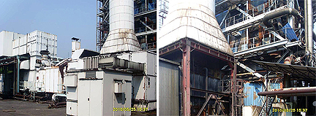

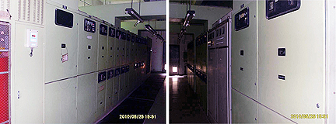

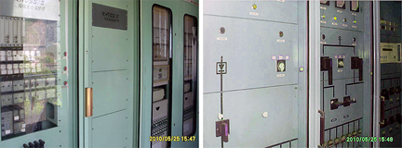

Asking Price; US $7.75 FOB China port

Gas Turbine
Manufacturer: Alstom, France
Model: PG6551B
Controls: Mark V
Fuel: LFO, HFO 180
Year Manufactured: 1998

1.1.2 Main Equipment
Generator
Manufacturer: Alstom, France
Model: T190-240
Rated Capacity: 37000KW
Rated Voltage: 1100V
Rated Current: 427A
Frequency: 50Hz
Speed: 3000rpm
Power Factor: 0.8
Cooling: Air
Connection Type: Y

Exciter
Model: KJ70-10,5 phase. Non Fuse
Rated Output: 142.5KW
Rated Voltage: 264V
Rated Current: 540A
Frequency: 200Hz
Exciter Current: 63A
Cooling: Air
Exciter Voltage: 121V

Compressor
Type: Air-Flow Type
Speed: 5114rpm
Exhaust Temp.: 315C
IGV Type: Hydraulic Adjustable
Series: 17

Turbine
Type: Single Axis, Axial Flow
Series: 3
Speed: 5114rpm
Nozzel Type: Fixed
Inlet Temp.: 1093C
Exhaust Temp: 529-544C

Combustion Chamber
Type: Can-Type Turn Flow
Quantity: 10
Spark Plug: 2
Flame Detector: 4
Nozzle: 10

1.1.3 Auxiliary Equipment
Start Devise: 1
Load Gearbox: 1
Aux. Gearbox: 1
Fuel System: 1
Lubrication System: 1
Hydraulic Oil System: 1
Atomizing Air Sys: 1
Cooling Water Sys: 1
Heater: 1
Turbine Fan: 1
Light Oil Mod. Sys: 1
Heavy Oil Pre-treat Sys: 1
Vanadium Inhibit Sys: 1
Water Clean Sys: 1
Flue Gas Baffle Sys: 1
Electrical Sys; 1
DC Sys: 1
CO2 Extinguishing Sys: 1

1.1.4 Gas Turbine History
Start Up: 10/29/97
Shut Down: 07/26/07
Total Hours: 34522
HFO Run Hrs: 30272.7
LFO Run Hrs: 4239.7
Start-Ups Attempts: 2793
Ignition Failures: 61
Total; Starts: 2854
Trip Times: 238
Total Output (MWh): 1025355
OH: 3 (01/2000, 02/2002, 01/2008)
Major OH: 2 (02/00, 01/03)
Other Major Repairs: 2 (02/99, 01/03)
Hours Since Major OH: 921
Last Time Trial: 10/19/08

Notice:
1.Unit jiggered 24Hrs each month since shut sown
2. 2006 OH-replaced nozzles, rotor blade, complex rings

1.1.5 Turbine Spare Parts(See appendix)
1.1.6 Special Tools of some
1.1.7 Drawing is complete

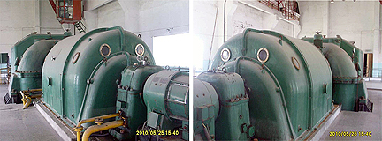

1.2 Steam Turbine
Manufacturer: Nanjing Turbine Electrical Machinery
Model: L18-3.43-1
Power: 18Mw
Speed: 3000rpm
Main Steam Pressure: 3.43Mpa
Main Steam Temp: 440C
Main Steam Flow: 66.5T/h
Cooing Water Temp: 25C

Steam Turbine Generator
Manufacturer: Nanjing Turbine Electrical Machinery
Model: L18-3.43-1
Power: 18Mw
Voltage: 10.5Kv
Current: 123.7A
Frequency: 50Hz
Speed: 3000rpm
Power Factor 0.8
Cooling: Air
Exciter Voltage: 175V
Exciter Current: 340A

1.2.2 Auxiliary Equipment
1-Condenser: N-2000-2
1- Shaft Seal Heater: JQ-16-2
1- Water Jet Air Extractor: TD-18
1- Oil Cooler: YL-40
1-Oil Seal: Ym3
3-Oil Pumps:
4-Water Pumps

1.2.4 Turbine Spare Parts (See appendix)
1.2.5 Special Tools of some
1.2.6 Drawing is complete

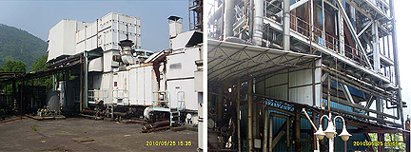

1.3 Heat Recovery Steam Generator (HRSG)
Start Date: 10/10/98
Stop Date: 06/26/07
Manufacturer: Nanjing Turbine Electrical Machinery
Evaporation Capacity: 68.8T/h
Evaporation Pressure: 3.53MP
Evaporation Temp: 445C
Medium-pressure Air Pocket
Working Pressure(Design): 3.92MP
Low-pressure Rated
Evaporation Capacity: 10.6T/h
Low-pressure Rated
Evaporation Pressure: 0.35MP
Low-pressure Rated
Evaporation Pressure: 147.2C
Feedwater Temp (Design): 147.2C
Condensed Water temp: 40C
HRSG Exhaust Gas Temp: 160C
Exhaust Gas Flow: 491T/h

1.3.2 Main Pressure-containing Member & Auxiliary Equipment
1-Air Pocket: 22m3
1-Med. Press. Superheater: Extended Surface Tube,2.65m3
1-High Press. Vaporizer: Extended Surface Tube,8.3m3
1-Economizer: Extended Surface Tube,4.5m3
1-Low-press. Evaporimeter: Extended Surface Tube,6.8m3
1-Low-press. Seperator: 1.0m3
1-Feed Water Tank: 45m3
1-Overheated Steam Attemperator
6-Water Pumps & Various Safety Valves

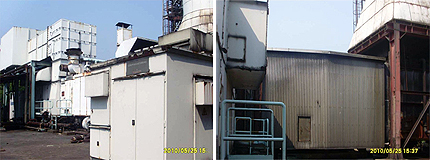

1.3.4 HRSG Standby Redundancy
1.3.5 Relative Complete Drawing

1.4 HFO Treatment Equipments
Manufacturer: Alfa-Laval Germany
Total Flo: 22 m3/h
Flow of each Line: 11 m3/h
Treating Method: Two Stage Washing Separating Method

1.4.2 Auxiliary Equipment
Transport Mod for Demulsifier Unit: 1
Demulsifier Unit: 1
Heating Unit: 1
Scouring Water Unit: 1
Mixing & Separating Mod: 2
Waste Water Treating Sys: 1
Start Date: Jun 6th,1998
Stop Date: Jul 26th,2007
Total Running Hours: 24632hs

Starting Date | Jun 6th,1998
Stop Date | Jul 26th,2007
Total Running Hours | 24632hs

1.4.4 Heavy Fuel Oil Treating Unit Standby Redundancy(see attached)
1.4.5 Complete Special Tools
1.4.6 Complete Drawing

1.5 Chemical Water Treatment Equipment
Start Date: Jul. 1998
Stop Date: Jul. 26, 2007
Manufacturer: CMEE, Shanghai
Outside Boiler H2O: Handling by first-class desalting water Treatment Method
Inside Boiler H2O: Handling by first-class desalting water Treatment Method

1.5.2 Main Equipments
1-Clean Water Tank Φ： 6480、V：200M3
2-Activate Carbon Φ： 2000、V：8-12m/h
2-Cation Bed Φ： 1500、V：10-12m/h
2-Anion Bed Φ： 1500、V：10-12m/h
2-Co2 Remover Φ： 800、Q：20t/h
2-Intermediate H2O Tank V2.5M3
1-Demineralize H2O Tank 6480、V：200M3
2-Acid-Base Tank Φ： 1500、V：5M3
1-Acid-Base Tank ： 800、V：0.5M3
1-Ammonia Solut. Tank ： 1M3
9-Pimps

1.5.4 Chemical Water Treatment Equipments Spare Parts (See appendix)
1.5.5 Laboratory Instrument a surname.

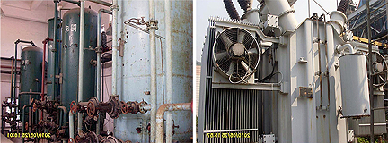

1.6 Cooling Tower Equipment
Manufacturer: Zhejiang Lianfeng Group
Cooling Capacity
3-Cooling Fan: 132KW motor
3-Electrical Valve: DN600, PN10
Start Date: 1998
Stop Date: Jul. 26, 2007

1.7 Circulating Water Equipment
Manufacturer: CMEE, Shanghai
Total Flow: 5256m3/h
2-600S32B Pump: 2628 m3/h、with 250KW、6000V motor
2-Electrical Valve: DN600, PN10
Start Date: Sep. 1998
Stop Date: Jul. 26, 2007

1.8.1 Transformer Specification
1-Low Voltage Plant Transformer
1-Low Voltage Standby Plant Transformer
Manufacterer: Changzhou Huadi Special Transformer co.,ltd
Model: SC-2000/6 SC-2000/6
Rated Capacity: 2000KVA 2000KVA
Rated Voltage: 6/0.4KV 6/0.4KV
Cooling Method AN AN
Connection: D/YN.11 D/YN.11
Insulation: AC25 AC25
Manufacturing No.: 97-034-066 97-034-065
Commissioned September, 1997 September, 1997
Decommissioned: Operation Operation

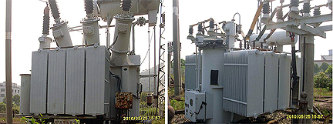

1.8.2 Major Equipment
1-6KV Switchgear
1-400V Distribution Cabinet
1-Protection devices
1-DC System: 3GFM2-1000AH 6V
1-UPS System: 20KVA

6KV switchgear
400V Distribution Cabinet
Protection devices
DC System | 3GFM2-1000AH 6V
UPS System | 20KVA

1.9 Auxiliary System Equipments

DCS Control System
Supplier: CMEE. Shanghai

Air Compressor System
2-M22 Screw Compressor Ingersoll-Rand
2-Heatless Regenerative Dryers Hangzhou
2-Air storage tanks
1-Foam generator
10-Diesel fire pumps: 200S-95
1-Regulators Pump: 21/2GC-6*3

Fire Extinguishing System
1-Electric Fire Pump: 200S-95 110KW
Supplier: CMEE. Shanghai

