 | CFAS Enterprises Inc.  After Market Utility Power Equipment Brokerage  Mailto:Staff@CFASPower.com  Turbine URL: http://CFASPower.com/Index.html  Reciprocating URL: http://CFASPower.com/Recips.html
GTG_1551GR_13900 KVA_50HzGenend.doc

1 x Used 13,900 KVA 50 Hz 1,500 rpm,6.3kv, PF 0.72 Alternator

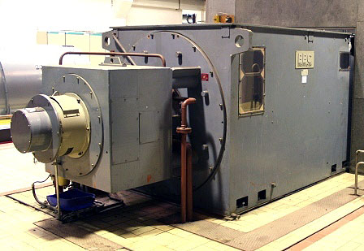

Asking Price: EURO 250,000

Condition: Dismantled, inspected, serviced, stored indoors
Total Operating Hours: 54,000
Year Manufactured : 1980
Location: Europe

SCOPE OF SUPPLY:

The complete alternator as arranged is available and contains the following parts:

- Alternator with exciter (diodes);
- Alternator air coolers;
- Electrical installation (voltage regulation, protection, star point, etc.);
- Manuals, drawings and documentation as far as available;

DELIVERY TIME:

Available immediately (subject to prior sale).

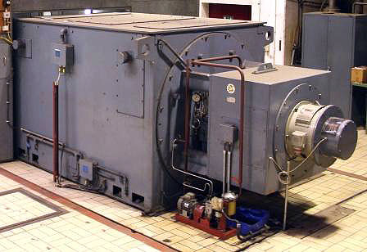

ALTERNATOR

Type : WG 1000 irb4M
Output : 13,900 kVA
Power factor : 0.72
Voltage : 6.3 kV
Current : 1374 A
Speed : 1500 rpm
Construction : Serviced
Protection : IP 44
Isolation class : B
Cooling air temperature (max. outlet) : 40 ºC
Cooling air flow : 8 m3/s
Cooling water flow : 57 m3/h
Cooling water temperature (max. inlet) : 32 ºC
Heating amount : 291 kW
Excitation (brushless) : 97 V – 580 A

EXCITER

Type : WE500aa10/4
Voltage : 92.5 V – max. 96 V
Current : 510 A – max. 566 A
Output : 81.8 kVA

