 | CFAS Enterprises Inc.  After Market Utility Power Equipment Brokerage  Mailto:Staff@CFASPower.com  Turbine URL: http://CFASPower.com/Index.html  Reciprocating URL: http://CFASPower.com/Recips.html
GTG_1549RC_GE8000KVA_Genend.doc

1 x Used 6566/8000KVA G.E. AC Generator 3/60/4160V, 3600 RPM

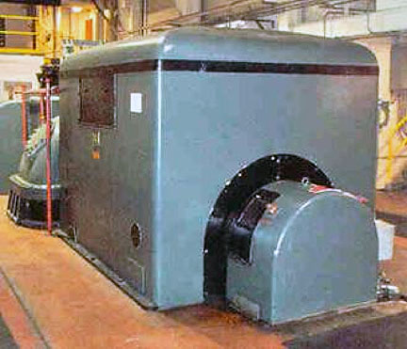

Asking Price: US $90,000.00 on site . As is , where is
Removal estimate:: US $8,000.00
VOLTAGE REGULATOR INCLUDED
YOM:1948
Immediate Delivery

GE AC Generator
Rating: 8000 KVA
Frequency: 60
Voltage: 4160V
Speed: 3600 RPM
Exciter: 33KW
125VDC
Armature Amps 911
Field Amps: 161
P;es: 2-pole
Phase: 3 phase
110°C On Armature by detector
125°C on Field by resistance
Max cold air temperature: 40°C
Inlet water: 70°F
Armature Volts: 4160
Power Factor: 0.99
New cooler Installed: 2000
Originally rated at 6566 KVA. Rerateddue to upgraded cooler

Approximate Dimensions: 16' - 0"L x 7' - 8"W x 8' - 0"H
Approximate Weight: 46,900 Lbs

