 | CFAS Enterprises Inc.  After Market Utility Power Equipment Brokerage  Mailto:Staff@CFASPower.com  Turbine URL: http://CFASPower.com/Inventory.html  Reciprocating URL: http://CFASPower.com/Recips.html
GTG_1545MATI_KongMo_1400KW50Hz.doc

Kongsberg Dresser Rand 1400kW 50Hz Mobile Turbine Diesel Generator Set

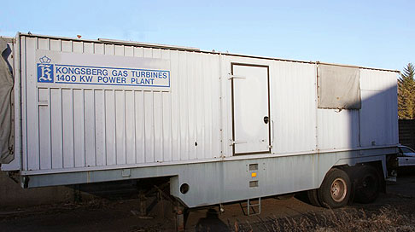

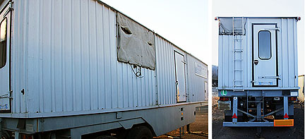

Asking Price: US $400,000
Location: Switzerland - Ready For Delivery

The unit is available any time for inspection. It has been hardly used and it is perfectly running.
70 Hours Since New
Excellent Condition
Last start-up 2005

Manufacturer: Konsberg Dresser
Engine: Turbine Viking Model 2 -3 c
Brand: Konsberg Dresser
Year Manufactured: 1974
Serial no. 1348
Fuel Type: Diesel
Cooling: Air Cooled
Rating: 1970Kw
Voltage: 220v
Fuel Tank: 8000 lt
RPM: 1500
Condition: Low Hours – as new

Scope of Supply
Turbine, Gear Box, Generator BOP
Spare parts: (Additional Spares parts can be arranged through owners)




