 | CFAS Enterprises Inc.  After Market Utility Power Equipment Brokerage  Mailto:Staff@CFASPower.com  Turbine URL: http://CFASPower.com/Inventory.html  Reciprocating URL: http://CFASPower.com/Recips.html
GTG_1541SRI_W251B11CC_50Hz.doc

Westinghouse W251B11 136mw 50hz HFO Combined Cycle Power Plant

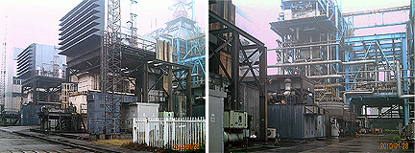

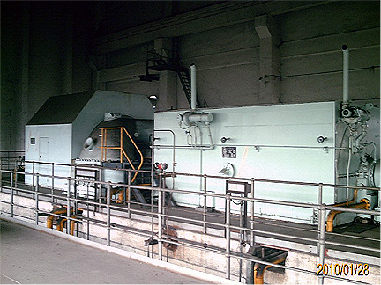

Asking Price: .US.$5,500,000 FOB

Unit No. 1
Westinghouse W251B11 50mw Gas Turbine
Start: 2005
Stop: 2007 August
Running Hours: 33309
Last Overhauled: 2007 May.
Fuel:: No. 180 Heavy Fuel Oil 110。C 5427
Speed: 3000rpm
Compression Ratio: 15:1
Alternator: Brush Uk
Rating: 65882kva
Out Put 42.51mw
Voltage: 11.5kva
Frequency: 50hz
Spped: 3000rpm.
Pf.: 0.85

Unit No. 2
Westinghouse W251B11 50mw Gas Turbine
Start: 2005
Stop: 2007 August
Running Hours: 33948
Last Overhauled: 2006 Dec.
Fuel:: No. 180 Heavy Fuel Oil 110。C 5427
Speed: 3000rpm
Compression Ratio: 15:1
Alternator: Brush Uk
Rating: 5882kva
Out Put: 42.51mw
Voltage: 11.5kva
Frequency: 50hz
Speed: 3000rpm.
Pf.: 0.85

Steam Turbine:
QFW-36-2: 36mw
Start: 2005
Stop: 2007 August
Running Hours: 43709
Last Overhauled: 2006.Jan.
Fuel:: No. 180 Heavy Fuel Oil 110。C
Alternator: Najing Steam Turbine Group
Rating: 45mva
Out Put: 36mw
Voltage: 10.5 Kva
Frequency: 50hz
Speed: 3000rpm.
Pf. :0.8
Boiler: Hanzhou Boiler Manufacture

