 | CFAS Enterprises Inc.  After Market Utility Power Equipment Brokerage  Mailto:Staff@CFASPower.com  Turbine URL: http://CFASPower.com/Index.html  Reciprocating URL: http://CFASPower.com/Recips.html
GTG_1528SC_GELM5000_60Hz.doc

1 x GE LM5000-GD-NGA 34800 KW STG Gas13800 V, 3 PHASE 60HZ

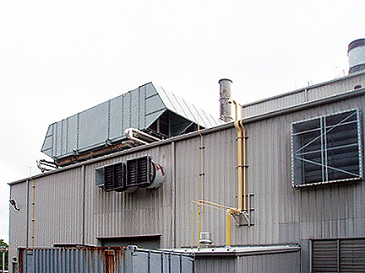

Asking Price: US $1.9MM

GAS TURBINE:
Manufacturer: General Electric
Packaged by: Stewart & Stevenson
Model number: LM5000-GD-NGA
Rating: 38400 kw
Fuel: Natural Gas
Power turbine model number: T-5000-1
GENERATOR:
Manufacturer: Brush
Rating: 38400 kw
Frame: BDAX75-290E
Voltage:: 1380v
Phase: 3
Frequency:` 60 hz
PF: 1.0
Steam injected for Nox control
Heat rate simple cycle: 10,506 btu/kwh
Heat rate combined cycle: 9,075 btu/kwh
Complete plant with all associated equipment.
History:
Year built: 1992
Year Shutdown: 2010
Lift time hours: 53,786 hours
Hours since last overhaul: 8,716

