 | CFAS Enterprises Inc.  After Market Utility Power Equipment Brokerage  Mailto:Staff@CFASPower.com  Turbine URL: http://CFASPower.com/Index.html  Reciprocating URL: http://CFASPower.com/Recips.html
GTG_1523SC_All501Mob_60Hz.doc

3 x RR Allison 501KB 3000 KW 12500/13200V 60HZ, Mobile Units

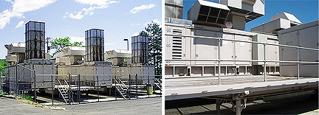

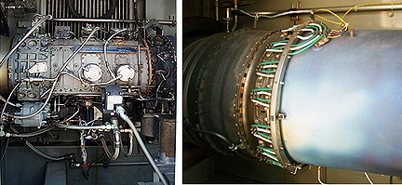

US $ 830,000 Each
Fuel: #2 Fuel Oil
Starter: Diesel Start
Trailer Mounted
Updated Controls
EN Generator
Air Cooled
Output: 3775 Kva / 3020 Kw
Voltage: 12500 / 13200 V
Speed: 1800 Rpm
Phase: 3
Frequency: 60 Hz
OEM Maintained
Hours / Starts
Unit 1 - 2045 / 1061
Unit: - 1495 / 955
Unit : - 2135 / 1240
Year Mfg.: 1979
Shut Down: February 2010

