 | CFAS Enterprises Inc.  After Market Utility Power Equipment Brokerage  Mailto:Staff@CFASPower.com  Turbine URL: http://CFASPower.com/Index.html  Reciprocating URL: http://CFASPower.com/Recips.html
GTG_1475SS_Kaw_M1A03.doc

1 x 1990 Kawasaki 1200KW 50HZ HFO Fired Gas turbine Generator

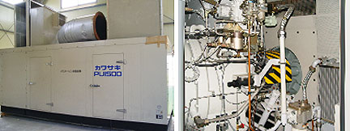

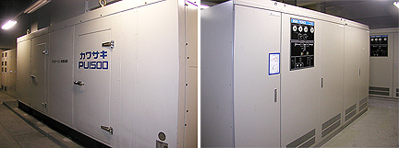

Asking Price: US $135,000
Remove and properly warehouse stored

Turbine Maker: Kawasaki
Model: M1A-03
Type: T1500A-BER
Engine Output: 1200kw
Engine Speed: 1500rpm
Frequency: 50hz
Year: 1990

Generator Maker: Fuji Electric
Type: GFV7561A-4
Generator Output: 1500kva
Rpm: 1500rpm
Hertz: 50hz
Volts: 6600v
Phase: 3
Poles: 4
Power Factor: 0.8
Year: 1990

Fuel Oil: Heavy Fuel Oil “A”
Used Hour: 93hrs
Total Dimension; 5800 X 2500 X 2500mm
Weight: 15ton

Unit is in very good conditions with completed scope and containerized packing.

