 | CFAS Enterprises Inc.  After Market Utility Power Equipment Brokerage  Mailto:Staff@CFASPower.com  Turbine URL: http://CFASPower.com/Index.html  Reciprocating URL: http://CFASPower.com/Recips.html
GTG_1472PV_LM6000PA.doc

1 x 1996 GE LM 6000PA 47.3Mw 50Hz Combined Cycle Cogeneration Plant

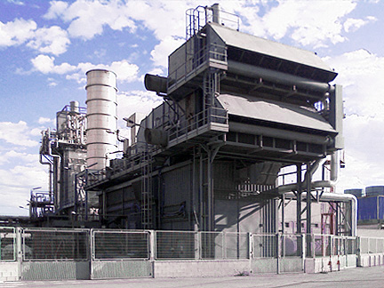

Asking Price: Euro 5.5 MM
Dismantling Cost: Euro 375,000
Location: Europe
Total Hours: 39,000 hours

Gas Turbine: General Electric LM6000PA
Rating: 39Mw
Fuel: Natural Gas Fuel
Controls: Mark V
Year: 1998.
Generator: GEC Alsthom
Rating: 48,76mva
Voltage: 11kv
Frequency: 50hz
Year: 1996

Heat Recovery Steam Generator: Without Post Combustion
Two Pressures 52bar @ 440c (44ton/H), 4bar At 188c (13ton/H). 35m By Pass Stack With Hydraulic System.
Year 1996.

Back Pressure Steam Turbine: Siemens T-5452
Rating: 4.5 Mw
Voltage: 6kv
Frequency: 50hz
Inlet Pressure: 52 Bar At 440c
Outlet Pressure: 4 Bar At 188c
Steam Production: 44 Steam Ton/H

Condensing Steam Turbine: Allen S22-630
Rating: 3.8 Mw
Voltage: 11kv
Frequency: 50hz
Inlet Pressure: 4 Bar At 188c, 34 Ton/H
Year: 1995
Condensing Steam Turbine: Indar Lsa-710-L/A4
Year: 1996

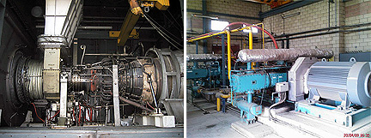

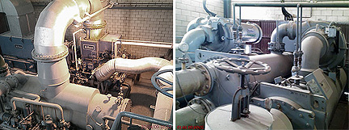

Auxiliary Systems:

Main Step-Up Transformer: OASA 56000/112
56MVA
110KVolt-11KVolt.
Year 1996
Without PCB/PCT
Aux. Transformer: OASA 2200/11
2,2MVA
11KVolt-0.4KVolt
Year 1996.
Without PCB/PCT
Factory Transformer: OASA 12000/25
12MVA
11KVolt-25KVolt
Year 1996.
Without PCB/PCT
Main Breaker: Merlin Gerin Hexabloc
TH7
110KVolt
Year 1996.
2 x Other Breakers Generation
Auxiliary TRF, Line, Factory, Others): ABB. 11KVolt. Year 1996.

Natural gas compressors: Two Identical Units.
Prematecnica P166H180CS.
Burton Corblin 12000Nm3/h. 48bar.
Year 1996
Steam Condensor: GEA F1400/5000
Steam: 34Ton/h
Cooling Water: 1200 m3/h
Open Cycle Cooling Towers
2 x Vacuum Pumps
Year 1996

Air compressors:
2 x Atlas Copco GA15P
13bar
29,5liter/s
Year: 1996.

Cooling Gas Turbine Air inlet: Hermetic Centrifugal Liquid Chillers.
2 x Carrier 19XR5050437DFH52S with PIC II Controls
Refrigerant HFC-134a.

Fire fighting system:
On Main Transformer: Deluge Valve With Sprinklers; In The Plant: 4 Hydrants; Electrical Pump 95m3/h, Diesel Pump 95m3/h And Jockey Pump, Pressure Switches. 100.000 Litre Demineralised Water Tank.
On Gas Turbine Package: CO2 System, Fire Detectors, Natural Gas Detectors And Electronic Alarm Control.
Year: 1996.

Control Room: Gas Turbine Control: Mark V.
Plant Control: PLC Siemens Simatic S5; Operation Nodes: PCS5 and PCS7.

