 | CFAS Enterprises Inc.  After Market Utility Power Equipment Brokerage  Mailto:Staff@CFASPower.com  Turbine URL: http://CFASPower.com/Index.html  Reciprocating URL: http://CFASPower.com/Recips.html
GTG_1453ELE_AllisonMob_60Hz.doc

1 x Rebuilt Allison 501KB5 3MW Gas Turbine Mobile Genset

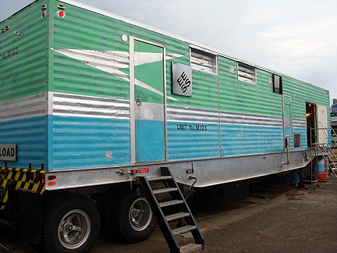

The Unit’s Aluminum Skin Is In Very Good Condition. It Has Been Cleaned And Can Be Painted To Buyer’s Preferences

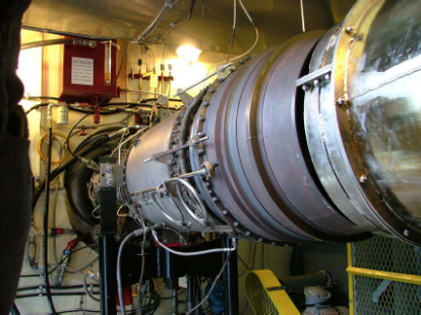
Allison 501 KB5 Turbine

Asking Price: US $785,000

Supplier. has completed the overhaul and load testing of a 3750 KVA (3MW) MobileGenerator Set to as-new condition with new PLC controls. The unit incorporates all the major componentsincluding intake and exhaust silencing and ducting into a single footprint with no additional peripheralattachments necessary. This unit served as standby power for the city of Fort Nelson, BC. The unit is BlackStart and can be configured to run on either Natural Gas or Liquid fuels. It can be configured to2400/4160 VAC 4 wire Wye Bus or 2400VAC 3 wire Delta.

***Unit is presently Gas. Can be delivered as Diesel at no additional cost

SPECIFICATIONS

Dimensions: Length: 42 Ft Width: 10 Ft Height: 12 Ft - 10 In
Weight: Rear Axles: 42,000 lbs
Fifth Wheel: 33,000 lbs
Total 75,000 lbs (weights approximate until scaled)

Engine: Allison Model 501KB5 Gas Turbine
Horsepower: 4800 Hp (maximum rated)
Time since overhaul: 0
Starter: FS100 Gas Turbine c/w 24VDC electric starter
Gearbox:
Make: Falk
Ratio: 7.684:1

Generator:
Make: Electric Motor Frame 9000
Serial : 173185611
RPM: 1800
Rated KVA: 3750
Volts: 2400/4160
Amps: 900/521
Phase: 3
Cycles: 60Hz
Hours since new: 23,000
Refurbished: 1988 (Beaver Electrical Machinery, Vancouver, BC)
Hours since refurbish: <1000 Inspected and tested: 2007 (Beaver Electrical Machinery)
Controls (NEW): PLC: Allen Bradley
ControLOGIX PLC and HMI programming:
Fuel Control NG: Optional Continental Controls Model AGV1O or WoodwardFuel Control Diesel: OEM Woodward
Generator Protection Relays: GEAutoSync: Basler
Control Power (NEW): 12OVAC
Battery Charger: Philtek Model PCVF
Inverter: Philtek Model PIV 750-120-N
Batteries: Magnacharge Model 27TMX 12VDC 1O5AH (10 Hr)
Trailer: Year and Make: 1974 Willock
Rebuilt: 2007 (all new brakes, drums, bearings

Supplier had all the existing protection relays tested and all are within specification. It was deemed prudentto offer the unit with these existing and calibrated components as a lower cost option. Should the clientwish the total upgrade of the protection and control, we will upgrade as requested.

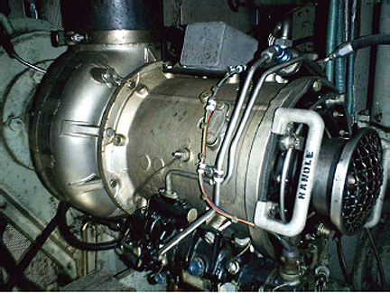
Allied Signal JFS100 Starter Turbine

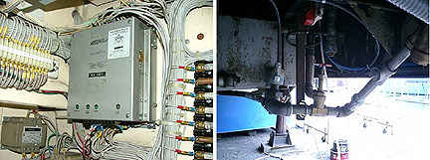
Woodward EG-A Liquid Fuel Governor. The unit can e converted to Natural Gas and either a Woodward Fuel Control Valve or Continental Control valve can e used
Fuel Piping Sensors connected to sub-flame day tank. The day tank is 1250 US gallons

The engine room has been upgraded to Class I Div II Electrical compliance.

Major Rebuild Features:

- New Allen-Bradley PLC Control System2. New Air Compressor and rebuilt Pneumatic Louvre Controls3. New Stainless Steel Pneumatic Exhaust Door4. New Brakes, Drums, Bearings and Air Glad Hands5. New 24VDC Battery Charger and Batteries6. New 125 VDC Control Power Inverter7. New 125 VVC Battery Charger and Batteries8. Zero Time OH Allison 501KB5 Gas Turbine9. Overhauled iFS 100 Starter Turbine10. All New Temperature, Pressure, and Vibration Transducers and Sensors11. Overhauled Woodward Liquid Fuel System and Governor

New Control Features:

- A-B ControLogix PLC2. RS View SE HMI3. Intel D965 PC. c/w 3 Removable 320GB Hard Drives4. Samsung 22" LCD Screen5. DVD RW Burner6. LAN and many more features

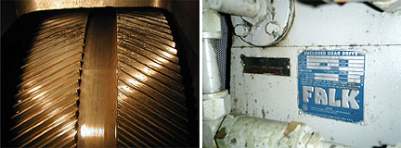
Falk Gearbox in New Condition

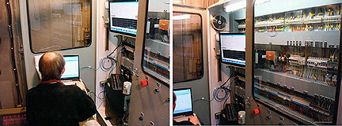
Control Room

All control wiring is new. The unit is not presently configured for remote start and CB closure. Dataacquisition is limited to all engine and auxiliary systems. Full SCADA can be added as an option at theclient's request.

ALLIED SIGNAL 3FS100 STARTER TURBINE

In September 2008, load tests were done up to 1.5MW using a Finning Load Bank. All systems and meterschecked OK. The Genset is ready to be installed for standby power or to connect to a grid.

Supplier can provide a Natural Gas Conversion Fuel System and can upgrade the HV and GeneratorProtection Systems to provide remote start and SCADA. These can be quoted upon request. Interestedparties can view the unit at our premises and witness a

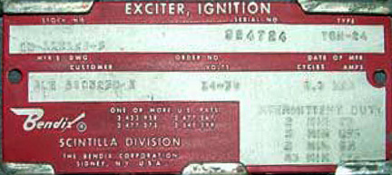
Bendix Plate

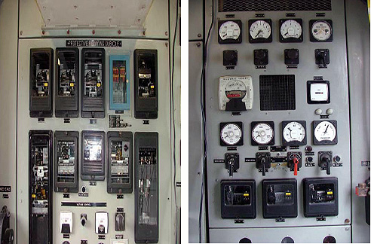
Compton Meters and Generator Protection.

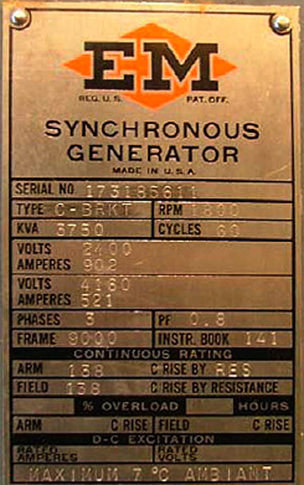
Generator Tag

