 | CFAS Enterprises Inc.  After Market Utility Power Equipment Brokerage  Mailto:Staff@CFASPower.com  Turbine URL: http://CFASPower.com/Inventory.html  Reciprocating URL: http://CFASPower.com/Recips.html
GTG_1402DS_Fm9171DF.doc

8 x New PG9171-E 123MW/50HZ Dual Fuel Turbines

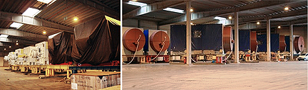

Asking Price: ……………………………………........... Euro 31.5 MM each

Designed for High Ambient Temperatures
Delivery time: Immediate
Warranty: Full, 18 months from delivery, or 12 month operation.
Payment: LC
Validity: 30 days – subject to prior sale –

Package: 106 Ft Long 36 Ft High (Air Intake) X 10 Ft Wide Plus Electrical House & Cooler Assy.

Dimensions: Weights:
Gas Turbine: 12.66 m x 5.03m x 5.05m 202 tons
Accessory Compartment: 8.45m x 3.45m x 4.10m 43.5 tons
Exhaust Plenum: 5.35m x 3.45m x 3.94m 22.5 tons
Exhaust Accessories: 5.55m x 3.65m x 0.76m 6.4 tons
Load Compartment: 5.30m x 1.90m x 1.05m 4.6 tons

