 | CFAS Enterprises Inc.  After Market Utility Power Equipment Brokerage  Mailto:Staff@CFASPower.com  Turbine URL: http://CFASPower.com/Index.html  Reciprocating URL: http://CFASPower.com/Recips.html
GTG_1372PE_1x6551CC.doc

1 X PG6551B On 1 STG Combined Cycle 52Mw HFO 50Hz Generating Plant

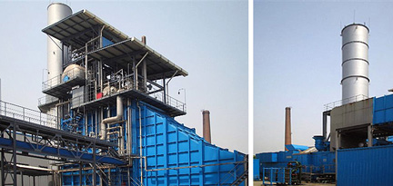

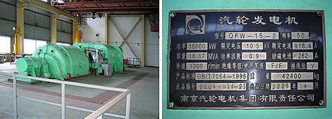

Asking Price: US $7,350,00 As Us/where is
Estimated removal, pack and shipped to port costs: US $750,000

Gas Turbine
Model: PG6551B
Package Serial No: 140510
GT Serial No: AD17988
Manufacturer: European Gas Turbine
Single Cycle Start Up Date: Sept,1999
Combined Cycle Start Up Date: April 2003
Gas Turbine Rated Power: 37MW At ISO Condition
Fuel: HFO

Steam Turbine
Rated Power: 14.5MW
Total Running Hour: 8031.4 Hours
Total Start Up Time: 748 Times
Steam Turbine Total Running Hour: 5720 Hours
- Intermediate Service Was Done On May,2006 Repaired First Stage Nozzle, Borescope Inspection Normal.
Inlet Temp: 1104∘C, Exhaust Temp:542∘C

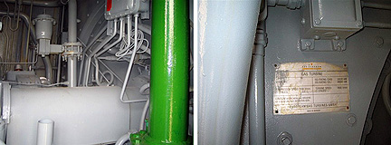
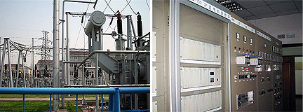

Scope Of Supply

Diesel Engine Start Up Model: 12V-71 460KW
Hydraulic Torque Convertor Model: E7wat
Auxiliary Gear Box Model: AA51DA
Fuel Front Stage Station Maker: Rotring Engineering
Close Loop Circulating Cooling Station Model: BRBO50 Cooling Area: 60m²
Washing System Model: RE-Clean HPI 961 Maker: Rotring Engineering
CO2 Fire Fighting System Maker: Rotring Engineering
Load Gear Box Model: TRL 65 CV Maker: Flender-Graffenstaden
HFO Fuel Treatment Plants

Generator
Model: T600C
Power: 45.647MVA
Voltage: 10.5kv
Current: 2510A
Frequency: 50Hz
Insulation Class: F
Excitor Model: TKJ70/10
Generator Air Vacuum Circuit Breaker Model: VA8031/12-2 PMA275
Auxiliaries Transformer Maker: AEG, Power: 400KVA
Excitor Transformer Dry Type: 10.5kv/2*160V
Gas Turbine Control Model: Mark V Triple Redundant Micro Computer Control
Generator Protection And Excitor Adjustment Type: IC
DC System Consist Of 2 Sets Of Charger Model: H3300, 92 Nos. Of Ni-Cad Batteries Model: SCM211
Cap: 211Ah

Steam Turbine
Model: N15-3.6/445
Manufacturer: Harbin Steam Turbine Work
Power : 15000KW
Speed: 3000rpm, Inlet Temp: 445∘C
Inlet Pressure : 3.6Mpa
Steam Flow: 66T/H
One Set Of High Pressure Oil Pump Model: 150AYII150x2B
Generator Model: YB355S3-2
Power: 220kw
3 Sets Of Circulating Water Pump Model: 600L-25A
Motor Model: YL355-6
Power: 200KW
2 Sets Of Auxiliary Circulation Water Pump Model: 300L-35A
Motor Model: Y280S-4 Power 75KW
2 Sets Of Close Circulation Water Pump Model: 8SH-13
Motor Model: Y250M-2 Power: 55kw
Condenser Type: Equal Split, Dual Channel, Surface Type
Condensation Rate: 50000kg/H
3 Sets Of Condenser Pump: 4N6x2 Motor: Y200L2-2 Power: 55kw
2 Sets Of Circulation Water Vacuum Pump Model: 2BE2030 Motor: Y250M-6 Power: 37KW
Cooling Tower Model: FBL(II) –1500x3
Manufacturer: Je Jiang Lian Feng Co
3 Sets Of Cooling Fan Model: LF-60II Motor YDT280S-4/6
Mian Steam Valve Model: T104.301Z
Auto Shut Down Model: T104.302Z
Manufacturer: Harbin Steam Turbine Work

Steam Turbine Generator
Model: QFW-15-2-10.5
Manufacturer: Nanjing Steam Turbine Work
Power: 15000kw
Voltage : 10.5kv
Insulation Class: F/B

AC Brushless Excitor
Model: TFLW70-3000
Manufacturer: Nanjing Steam Turbine Work
Voltage: 235V
Current: 297A
Permanent Magnet Excitor Model: TFY2.85-3000C
Excitor Adjustment: MAVR

Waste Heat Boiler
Model: Q393/542-66-3.82/450
**Non-Duct Burning, Horizontal Type, Single Pressure, Self De-Oxygen Natural Convection Boiler

Rated Steam Pressure: 3.82+/-0.05Mpa
Temp: 450+/-5∘C
Steam Rate: 66T/H, Medium Pressure Max Continuous Steam Flow: 66.7T/H
Steam Tank Pressure: 4.22Mpa
Exhaust Flow At ISO: 511T/H
Fume Temp: 542∘C
Feed Water Pump: FT85-540
Power: 220KW
Fume Door Model: TD10.89
Manufacturer: Hang Zhou Boiler Factory
Hydraulic Station: HGT007-32-01
Centrifugal Air Fan: C9-19/5A, 11KW
7 Sets Of Trolley Vacuum Circuit Breaker Model: KYN1B-10 Maker
Manufacturer: Chang Zhou Shum Yuan Electric Co
UPS Model: Galaxy PW, 30KVA
Manufacturer: Merlin Gerlin
SCR Rectifier Model: KCVA-20
Manufacturer: Xu Ji Electric
Generator Protection Model: PFB-100
Manufacturer: Xu Ji Electric
DCS Control For Thermal Control System Model: Freelance2000
Manufacturer: ABB
DEH System Model: 505E
Manufacturer: Woodward
Steam Turbine Security Monitoring System: Bently3300
SG8000 Maker: Harbin Automatic Control Engineering,
Steam Turbine Cranking System Model: C10-3.43/0.981
Manufacturer: Xin Hua Control Tech Development Centre.
Water Treatment System Model: GE90-30PLC
Manufacturer: GEFANUC

Chemical System
3 Sets Of Fresh Water Pump
Model: IS150-125-250
Motor: Y180M-A 18.5kw,
2 Sets Of Service Pump Model: 2BXG100WFB-A
2 Sets Of Clean Water Pump Model: IS100-65-200
De-Mineralize System Maker: Xi Shan Power Plant Boiler

Auxiliaries Factory
2 Sets Of Ion Exchanger Ø=2500 Hca =2500
2 Sets Of De-Carbonizer Ø=1400 Hf=2200
2 Sets Of De-Carbonizer Blower
Model: 4-72-12
2 Sets Of Middle Water Pump
Model: IH100-65-200
2 Sets Of Negative Ion Exchanger Ø=2500 Ha=2500
2 Sets Of Mix Ion Exchanger Ø=1600 H Ca =2500Ha=1000.
Regeneration System Maker: Xi Shan Power Plant Boiler Auxiliaries Factory
De-Acid Pump Model: 50FSB-20L
De-Alkaline Pump Model: 50FSB-20L
Acid Storage Tank Model: V=20m3
Alkaline Tank Model: V=20m3
2 Sets Of Water Pump Model:IH80-65-160

Ammonia Dosing System
2 Sets Of Ammonia Measuring Pump : Q=38L/H P=1.4Mpa
Ammonia Tank Ø=350x500

Boiler Phosphate System
3 Sets Of Phosphate Measuring Pump Q=16.09L/H P=6.4Mpa

Chemical Water Replenish System
2 Sets Of De-Mineral Water Pump
Model: CZ50-315
Motor : Y250M-2, 55KW
Steam Water Sampling System Model: SQZ-A-00

Transformers
1# Main Transformer Model:SF8-50000/110
2# Main Transformer Model: SF9-20000/110
2# Plant Transformer Model: SC-1600/10
3# Plant Transformer Model: SC-1000/10

